FULL STACK DEVELOPMENT

(SKILL ENHANCEMENT COURSE)

Experiment:1

1. Lists, Links and Images)

1a)

Aim: Write a HTML program, to explain the working of lists. Note: It should have an ordered list, unordered list, nested lists and ordered list in an unordered list and definition lists.

Source code:

<doctype html>

    <html>

        <head>

            <title>work with lists</title>

        </head>

        <body>

            <h1>Types of lists</h1>

            <ol>

                <li>ordered list</li>

                <li>unordered list</li>

                <li>description list</li>

                <li>nested list</li>

            </ol>

            <h2>Description about the Lists</h2>

            <dl>

                <dt>ordered list</dt>

                <dd>An ordered list starts with the ol tag. Each list item starts with the li tag.

                    The list items will be marked with numbers by default:

                </dd>

                <dt>unordered list</dt>

                <dd>An unordered list starts with the ul tag. Each list item starts with the li tag.

                    The list items will be marked with bullets (small black circles) by default:</dd>

                <dt>description list</dt>

                <dd>A description list is a list of terms, with a description of each term.

                    The dl tag defines the description list, the dt tag defines the term (name), and the dd tag describes each term:

                </dd>

                <dt>nested list</dt>

                <dd>Lists can be nested (list inside list):</dd>

            </dl>

            <h2>fullstack technologies</h2>

            <ol>

                <li>FRONT END TECHNOLOGIES</li>

                <ul type="square">

                    <li>HTML</li>

                    <li>CSS</li>

                    <li>JAVASCRIPT</li>

                </ul>

                <li>SERVER SIDE TECHNOLOGIES</li>

                <li>DATABASE SIDE TECHNOLOGIES</li>

            </ol>

      </body>

    </html>

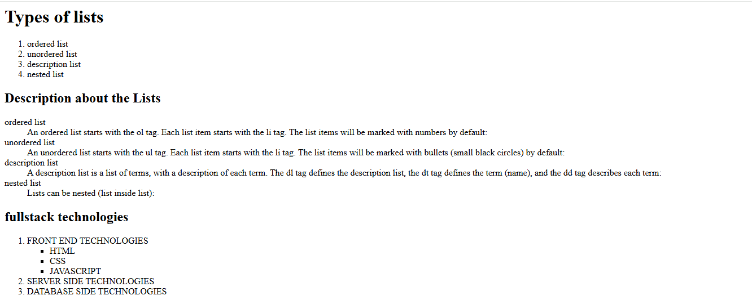

2b)

Aim: Write a HTML program, to explain the working of hyperlinks using tag and href, target Attributes.

Source code:

<!--working with anchor tag-->

<!doctype html>

<html>

    <head><title>navigation bar</title></head>

    <body>

        <div style="background-color: bisque;">

        <h3 align="center">ST.ANN'S COLLEGE OF ENGINEERING & TECHNOLOGY</h3>

        <a href="#" target="_blank">Home</a>

        <a href="1c.html" target="_blank">contact us</a>

    </div>

    <pre>

        HTML Links

        Links are found in nearly all web pages. Links allow users to click their way from page to page.

        HTML Links - Hyperlinks

HTML links are hyperlinks.

You can click on a link and jump to another document.

When you move the mouse over a link, the mouse arrow will turn into a little hand.

Note: A link does not have to be text. A link can be an image or any other HTML element!

HTML Links - Syntax

The HTML <a> tag defines a hyperlink.

The most important attribute of the a element is the href attribute, which indicates the link's destination.

The link text is the part that will be visible to the reader.

Clicking on the link text, will send the reader to the specified URL address.

HTML Links - The target Attribute

By default, the linked page will be displayed in the current browser window. To change this, you must specify another target for the link.

The target attribute specifies where to open the linked document.

The target attribute can have one of the following values:

_self - Default. Opens the document in the same window/tab as it was clicked

_blank - Opens the document in a new window or tab

_parent - Opens the document in the parent frame

_top - Opens the document in the full body of the window

    </pre>

    </body>

</html>

Output:

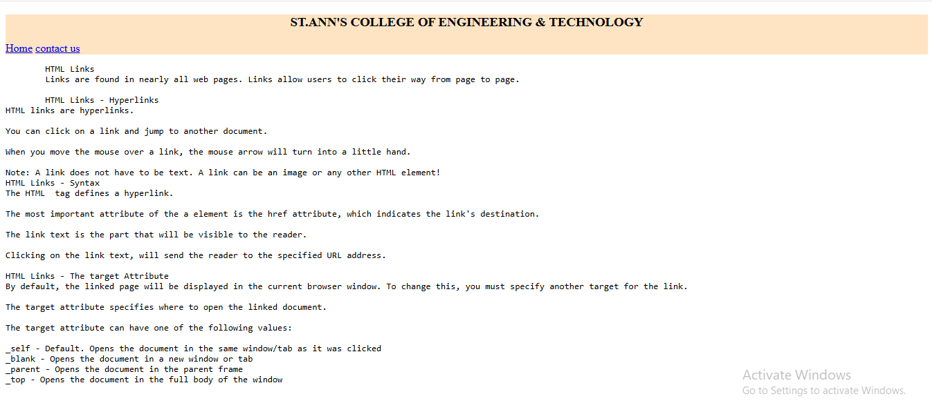

c.

Aim: Create a HTML document that has your image and your friend’s image with a specific height and width. Also when clicked on the images it should navigate to their respective profiles.

Source code:

<!--create a html document that has your image and yours friends image with specific height and width-->

<!doctype html>

<html>

    <head>

        <title>images</title>

    </head>

    <body align="center">

        <pre>Dr.P.Harini

            Head Of the Department,CSE.

            SACET.

        </pre>

        <a href="2a.html" target="_blank">

        <img src="csedept.jpg" alt="HOD" width="300" height="300">

    </a>

        <pre>Dr.P.Jagadesshbabu

            Principal,

            SACET.

        </pre>

        <a href="2a.html" target="_blank">

        <img src="eeedept.jpg" alt="Principal" width="300" height="300">

    </a>

    </body>

</html>

Output:

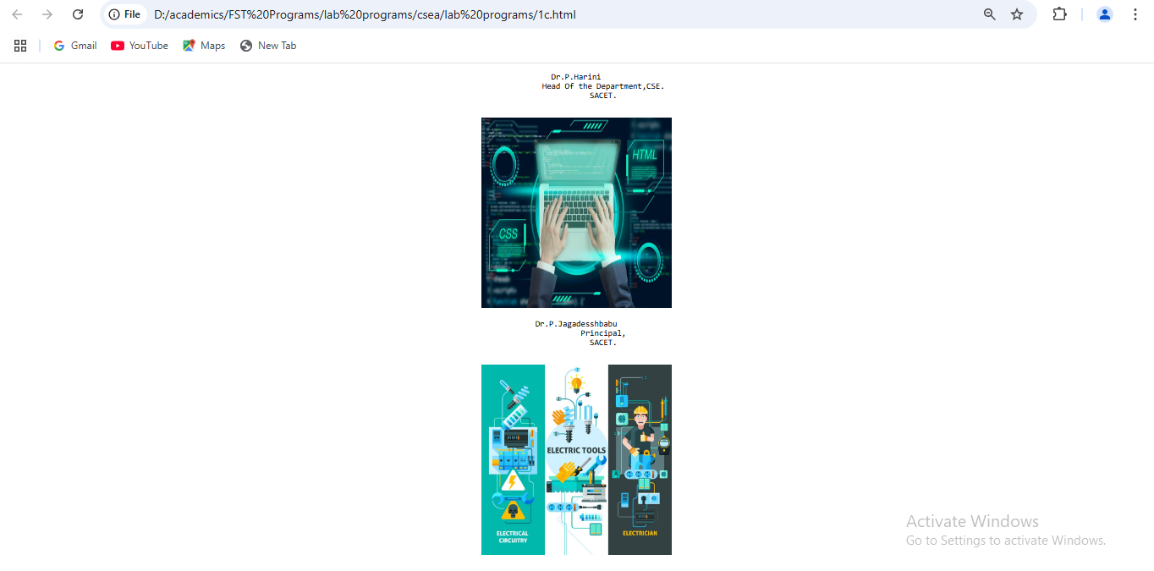

1d)

Aim:Write a HTML program, in such a way that, rather than placing large images on a page, the preferred technique is to use thumbnails by setting the height and width parameters to something like to 100*100 pixels. Each thumbnail image is also a link to a full sized version of the image. Create an image gallery using this technique.

source code:

<!-- Write a HTML program, in such a way that, rather than placing large images on a page,

the preferred technique is to use thumbnails by setting the height and width parameters

to something like to 100*100 pixels. -->

<!doctype html>

<html>

<head>

    <title>thumbnails</title>

</head>

<body>

<h3>gallery</h3>

<a href="hod.png" taget="_blank">

<img src="hod.png" alt="hod" widht="100" height="100">

</a>

<a href="mypic.jpg" taget="_blank">

<img src="mypic.jpg" alt="tss" widht="100" height="100">

</a>

<a href="hod.png" taget="_blank">

<img src="atp.png" alt="atp" widht="100" height="100">

</a>

<a href="hod.png" taget="_blank">

<img src="dnb.png" alt="dnb" widht="100" height="100">

</a>

<a href="hod.png" taget="_blank">

<img src="pvss.png" alt="pvss" widht="100" height="100">

</a>

<a href="hod.png" taget="_blank">

<img src="ramesh.jpg" alt="ramesh" widht="100" height="100">

</a>

</body>

</html>

output:

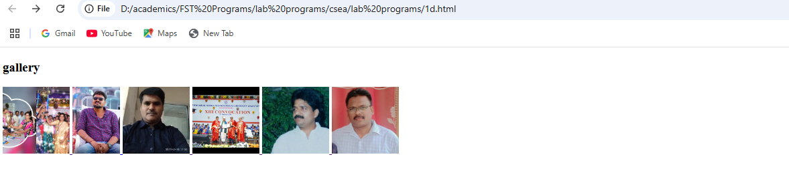

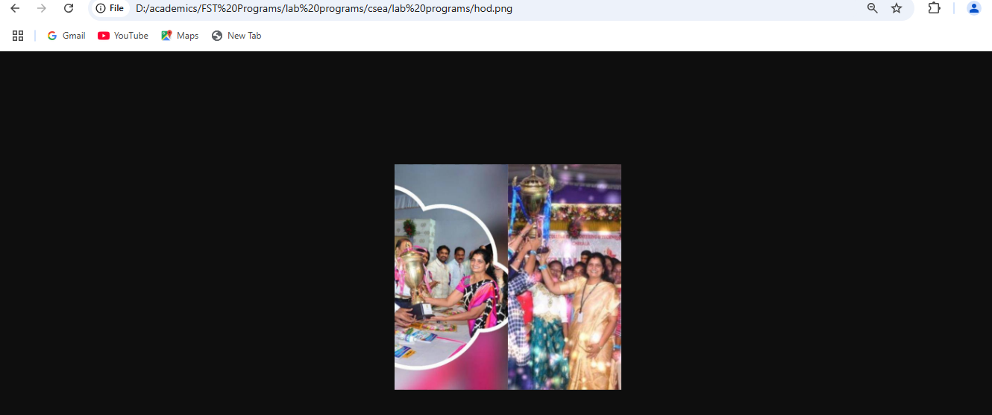

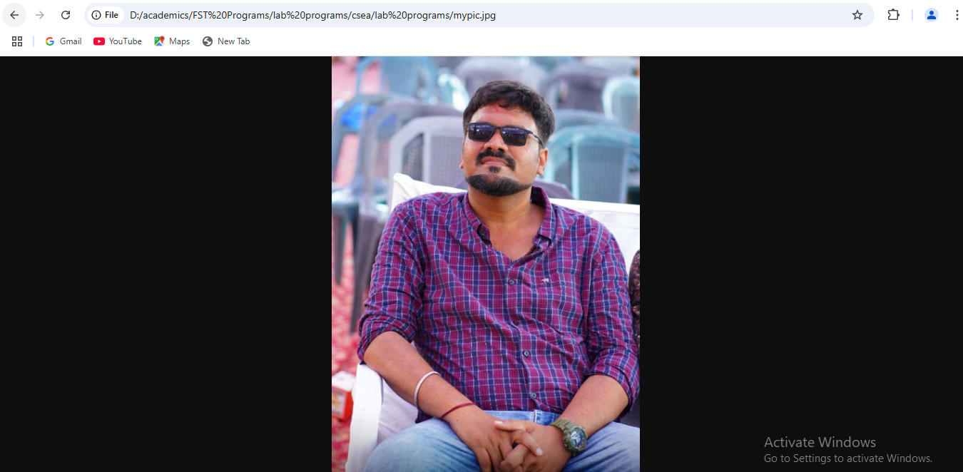

Experiment:2

HTML Tables

2a)

Aim:write a html program to explain the working of tables using <table><tr>td><th> tags and

attributes :border,rowspan and colspan.

Source code:

<!working with table,th,tr,td elements with cell spacing and cell padding

<!doctype html>

<html>

    <head></head>

    <style>

        table,th,td{

            border: 3px solid red;

            border-spacing: 20px;

        }

        th,td{

            padding:20px;

        }

    </style>

    <body>

        <table>

            <th>sino</th>

            <th>name of the student</th>

            <th>hallticket number</th>

            <th>phone number</th>

            <th>email id</th>

            <th>address</th>

            <tr>

                <td>1</td>

                <td>steve jobs</td>

                <td>566</td>

                <td>9885924188</td>

                <td>stevejobs@gmail.com</td>

                <td>kothapeta,chirala</td>

            </tr>

            <tr>

                <td>2</td>

                <td>steveharris</td>

                <td>567</td>

                <td>9885924189</td>

                <td>sacet623@gmail.com</td>

                <td>kothapet,chirala</td>

            </tr>

            <tr>

                <td>3</td>

                <td>jhon smith</td>

                <td>568</td>

                <td>9885924187</td>

                <td>jhonsmith2gmail.com</td>

                <td>iltd colony,chirala</td>

            </tr>

            <tr>

                <td>4</td>

                <td>petterpaul</td>

                <td>569</td>

                <td>9885924187</td>

                <td>petterpaul@gmail.com</td>

                <td>perala,chirala</td>

            </tr>

            <tr>

                <td>5</td>

                <td>richarson</td>

                <td>570</td>

                <td>9885924156</td>

                <td>ricjard@gmail.com</td>

                <td>perala,chirala</td>

            </tr>

        </table>

    </body>

</html>

Output:

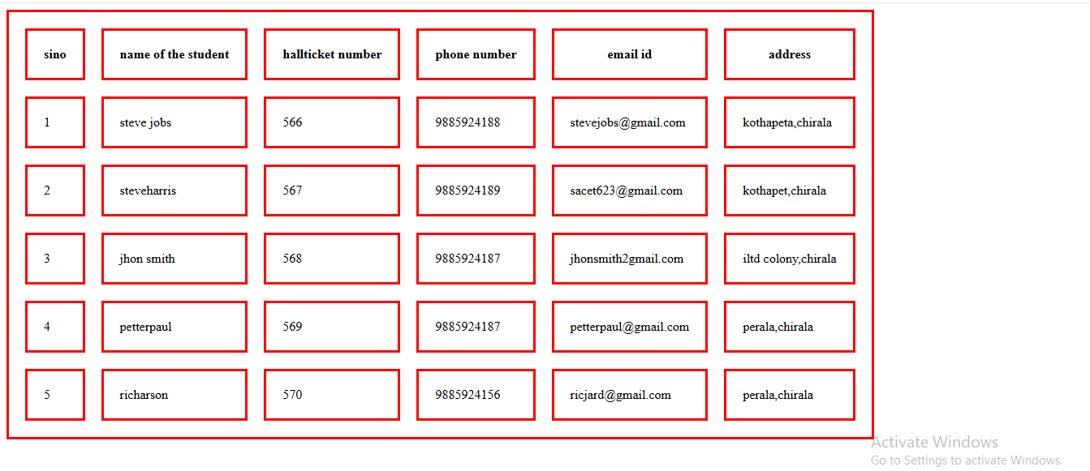

b. Write a HTML program, to explain the working of tables by preparing a timetable. (Note: Use tag to set the caption to the table & also use cell spacing, cell padding, border, rowspan, colspan etc.).

**SOURCE CODE:**

<!--working with table and colspan and rowspan-->

<!doctype html>

<html>

    <head></head>

    <style>

        th,td{

            padding:20px;

            border:2px solid red;

        }

    </style>

    <body>

        <table border="3" style="border-collapse: collapse;">

<caption>TIMETABEL</caption>

            <th>day</th>

            <th>9.00-10.00</th>

            <th>10.00-11.00</th>

            <th>11.00-12.00</th>

            <th>12.00-12.50</th>

            <th>12.50-1.50</th>

            <th>1.50-2.50</th>

            <th>2.50-3.50</th>

            <tr>

                <td>mon</td>

                <td colspan="3">lab</td>

                <td rowspan="6">lunch</td>

                <td>os</td>

                <td>java</td>

                <td>msd</td>

            </tr>

            <tr>

                <td>tue</td>

                <td>cns</td>

                <td>os</td>

                <td>java</td>

                <td colspan="3">msd lab</td>

            </tr>

            <tr>

                <td>wed</td>

                <td colspan="3">lab</td>

                <td>os</td>

                <td>java</td>

                <td>msd</td>

            </tr>

            <tr>

                <td>thu</td>

                <td colspan="3">lab</td>

                <td>os</td>

                <td>java</td>

                <td>msd</td>

            </tr>

<tr>

                <td>fri</td>

                <td colspan="3">lab</td>

                <td>os</td>

                <td>java</td>

                <td>msd</td>

            </tr>

            <tr>

                <td>sat</td>

                <td colspan="3">lab</td>

                <td>os</td>

                <td>java</td>

                <td>msd</td>

            </tr>

        </table>

    </body>

</html>

**OUTPUT:**

TIMETABLE

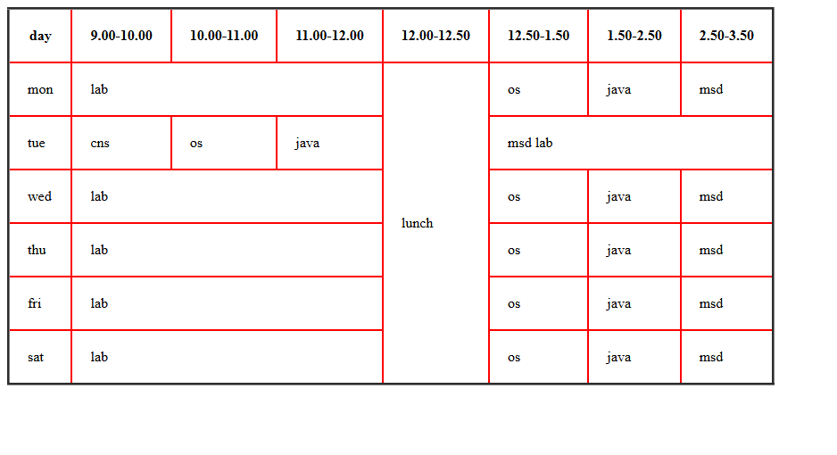

c. Write a HTML program, to explain the working of forms by designing Registration form. (Note: Include text field, password field, number field, date of birth field, checkboxes,radio buttons,list boxes using and two buttons ie:submit and reset. Use tables to provide a better view).

Source Code:

<!DOCTYPE html>

<html>

    <head></head>

    <style>

        table,th,td{

            padding:10px;

            border-spacing: 10px;

        }

        </style>

    <body  style="background-color: beige;">

        <form>

            <table>

                <caption>Registration Form</caption>

                <tr>

                    <td>

                    <label for="firstname">Enter first name</lable>

                </td>

                <td>

                    <input type="text" id="firstname" name="firstname" placeholder="enter firstname">

                </td>

                </tr>

            <tr>

                <td>

                    <label for="lastname">lastname</lable>

                </td>

                <td>

                    <input type="text" id="lastname" name="lastname" placeholder="eter lastname">

                </td>

            </tr>

            <tr>

                <td>

                    <label for="emailid">enter emailid</label>

                </td>

                <td>

                    <input type="email" id="email" name="email" placeholder="enter email id">

                </td>

            </tr>

            <tr>

                <td>

                    <lable for="password">new password</lable>

                </td>

                <td>

                    <input type="password" id="password" name="password" placeholder="set password">

                </td>

            </tr>

            <tr>

                <td>

                    <lable for="password">re-enter password</lable>

                </td>

<td>

                    <input type="password" id="password" name="password" placeholder="re-typepassword">

                </td>

            </tr>

            <tr>

                <td>

                <lable for="age">enter age</lable>

            </td>

            <td>

                <input type="number" id="age" name="age" placeholder="select age" >

            </td>

            </tr>

            <tr>

                <td>

                <lable for="dob">date of birth</lable>

            </td>

            <td>

                <input type="date" id="dob" name="dob"  >

            </td>

            </tr>

            <tr>

                <td>

                <span>gender</span>

            </td>

            <td>

                <label for="male">male</label>

                <input type="radio" id="male" name="gender"  >

                <label for="female">female</label>

                <input type="radio" id="female" name="gender"  >

                <label for="transgender">transgender</label>

                <input type="radio" id="transgender" name="gender"  >

            </td>

            </tr>

            <tr>

                <td>

                <span>Hobbies</span>

            </td>

            <td>

                <label for="tv">watching tv</label>

                <input type="checkbox" id="tv" name="hobbies"  >

                <label for="games">playing games</label>

                <input type="checkbox" id="games" name="hobbies"  >

                <label for="reading">reading books</label>

                <input type="checkbox" id="reading" name="hobbies"  >

            </td>

            </tr>

            <td>

                <label for="country">country</label>

            </td>

            <td>

                <select id="country" name="country">

                    <option value="">seelct your country</option>

                    <option value="india">india</option>

                    <option value="russia">russia</option>

                    <option value="australia">australia</option>

                </select>            </td>

            <tr>

                <td>

                    <lable for="comments">comments</lable>

                </td>

                <td>

                    <textarea id="comments" name="comments" placeholder="enter comments"></textarea>

                </td>

            </tr>

            <tr>

                <td>

                    <span>favourite food</span>

                </td>

                <td>

                    <input list="favfood" placeholder="favourite food">

                    <datalist id="favfood">

                        <option value="idly">idly</option>

                        <option value="idly">idly</option>

                        <option value="idly">idly</option>

                    </datalist>

                </td>

            </tr>

        <tr>

            <td>

                <button>submit</button>

            </td>

            <td>

                <button>reset</button>

            </td>

        </tr>

     </table>

        </form>

    </body>

</html>

Output:

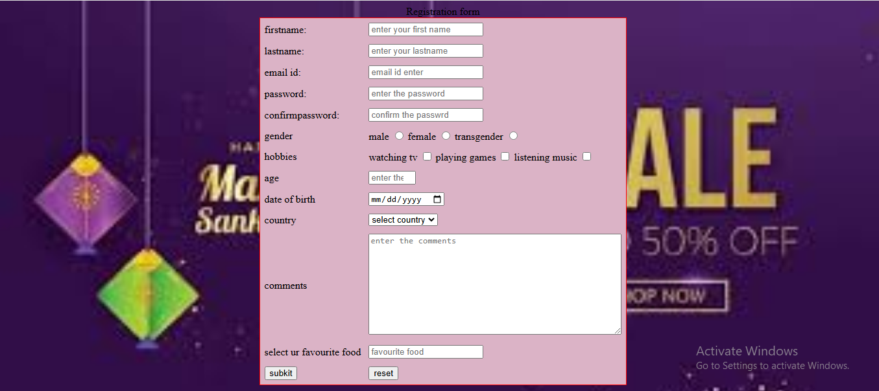

d. Write a HTML program, to explain the working of frames, such that page is to be divided into 3 parts on either direction. hyperlink. And also◊ paragraph, third frame ◊ image, second frame ◊(Note: first frame make sure of using “no frame” attribute such that frames to be fixed).

Source code:

<!DOCTYPE html>

<html>

<head>

    <title>Frames Example</title>

</head>

<body>

    <iframe src="image.html" width="1250" height="2100" frameborder="0"></iframe>

    <iframe src="paragraph.html" width="1200" height="100" frameborder="0"></iframe>

    <iframe src="hyperlink.html" width="1200" height="100" frameborder="0"></iframe>

</body>

</html>

Image.html:

<!DOCTYPE html>

<html>

<head>

    <title>Image Frame</title>

</head>

<body>

    <img src="ajio1.PNG" alt="Example Image" style="width:100%; height:100%;">

    <img src="ajio2.PNG" alt="Example Image" style="width:100%; height:100%;">

    <img src="ajio3.PNG" alt="Example Image" style="width:100%; height:100%;">

    <img src="ajio4.PNG" alt="Example Image" style="width:100%; height:100%;">

    <img src="ajio5.PNG" alt="Example Image" style="width:100%; height:100%;">

</body>

</html>

Paragraph.html:

<!DOCTYPE html>

<html>

<head>

    <title>Paragraph Frame</title>

</head>

<body>

    <p>This is an example paragraph to demonstrate the use of frames in HTML. Frames allow you to divide the browser window into multiple sections, each capable of displaying a different document.</p>

</body>

</html>

Hyperlink.html

<!DOCTYPE html>

<html>

<head>

    <title>Hyperlink Frame</title>

</head>

<body>

    <a href="https://www.example.com" target="_blank">Visit Example.com</a>

</body>

</html>

Output:

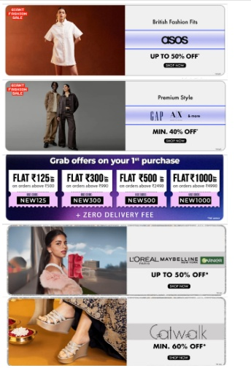

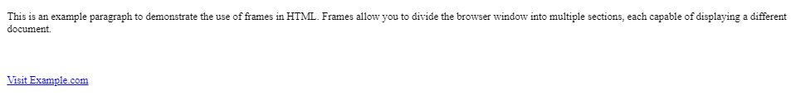

Experiment:3

HTML 5 and Cascading Style Sheets, Types of CS

a.Write a HTML Program that makes use of <article>,<aside>,<figure>,<figcaption>,<footer>,<header>,<main>,

<nav>,<section>,<div>,<span> tags.

**Souce code:**

<!DOCTYPE html>

<html>

    <head></head>

    <body>

        <section style="text-align: center;">

            <header>

                <h1>baapare shopping</h1>

                <nav>

                    <a href="#" target="_blank">home</a>

                    <a href="#" target="_blank">login</a>

                    <a href="#" target="_blank">registration</a>

                </nav>

            </header>

        </section>

        <main>

            <article style="border-style: double;">

                <h3 style="text-align: center;">welcome to bapaare online shopping</h3>

                <aside style="float:left;width:150px;height:170px;">

                    <figure>

                    <img src="shopping.jpg" alt="welcome image" width="100" height="100">

                    <figcaption>welcome</figcaption>

                </figure>

                </aside>

                <p>We appreciate that you chose us for your shopping. We value your trust and confidence in us.

                    We’re here to support you every step of the way. If you have any questions or need assistance, don’t hesitate to reach out to our support team.

                    Welcome to the bapaare family, where we take great satisfaction in helping people like you achieve needs through our Services.

                </p>

            </article>

            <div>

                <h4>AJIO is an online shopping platform  </h4>

                <span>that sells clothing, shoes, accessories, beauty products, home decor, and more. It's a digital commerce initiative of Reliance Retail and is headquartered in Bangalore, India.

                </span>

            </div>

        </main>

        <br>

        <footer>

            <div>

               <span>bapaare<span>

               <nav>

                <a href="#" target="_blank">who we are</a>

                <br>

                <a href="#" target="_blank">join our team</a>

                <br>

                <a href="#" target="_blank">terms and conditions</a>

               </nav>

            </div>

        </footer>

    </body></html>

Output:

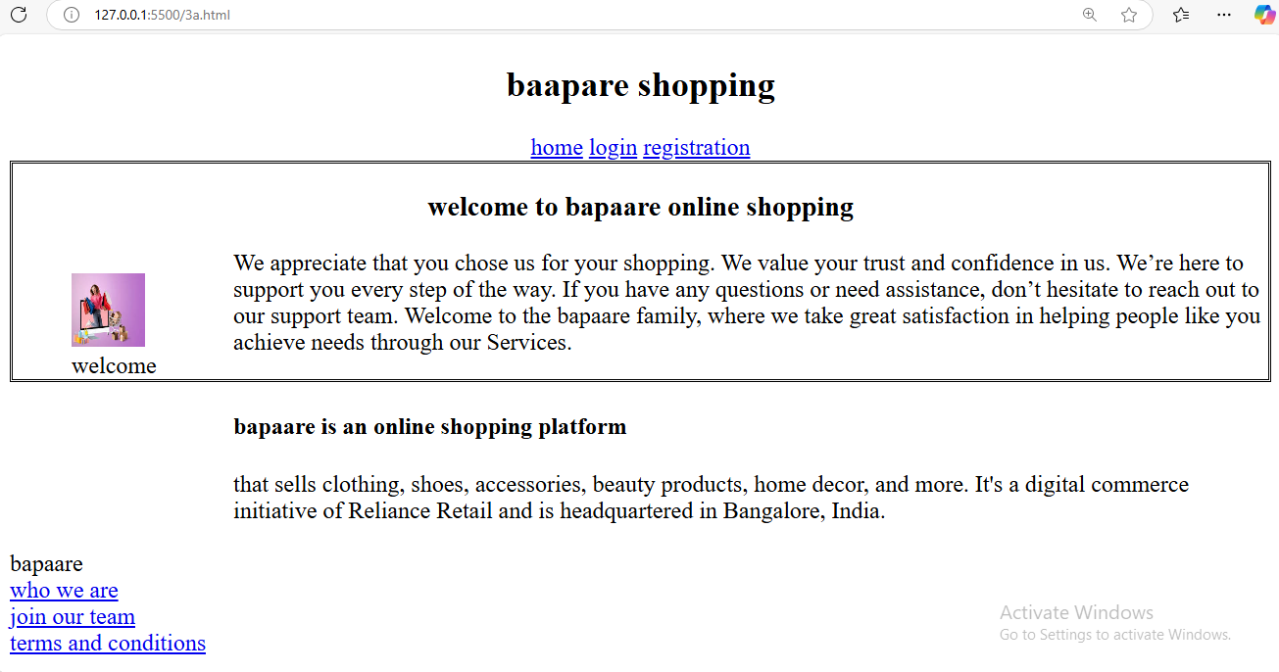

b. Write a HTML program, to embed audio and video into HTML web page.

**Source code:**

<!DOCTYPE html>

<html>

    <head></head>

    <body>

        <embed src="gabbar_singh.mp3">

            <br>

            <embed src="pspkmania.mp4" width="700" height="300">

    </body>

</html>

Output:

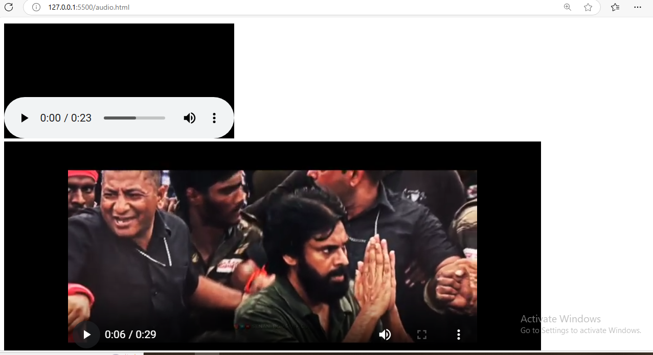

c. Write a program to apply different types (or levels of styles or style specification formats)- inline, internal, external styles to HTML elements. (identify selector, property and value).

Sourcecode:

<!DOCTYPE html>

<html>

    <head>

        <!-- external style -->

        <link rel="stylesheet" href="externalcss.css" type="text/css">

    </head>

    <!-- internal style -->

    <style>

        header{

            background-color: rgb(167, 112, 45);

        }

    </style>

    <body style="background-color: antiquewhite;">

        <section style="text-align: center;">

            <header>

                <!-- <!inline element-->

                <h1 style="color:gold">baapare shopping</h1>

                <nav>

                    <a href="#" target="_blank">home</a>

                    <a href="#" target="_blank">login</a>

                    <a href="#" target="_blank">registration</a>

                </nav>

            </header>

        </section>

        <main>

            <article style="border-style: double;">

                <h3 style="text-align: center;">welcome to bapaare online shopping</h3>

                <aside style="float:left;width:150px;height:170px;">

                    <figure>

                    <img src="shopping.jpg" alt="welcome image" width="50" height="50">

                    <figcaption>welcome</figcaption>

                </figure>

                </aside>

                <p>We appreciate that you chose us for your shopping. We value your trust and confidence in us.

                    We’re here to support you every step of the way. If you have any questions or need assistance, don’t hesitate to reach out to our support team.

                    Welcome to the bapaare family, where we take great satisfaction in helping people like you achieve needs through our Services.

                </p>

            </article>

            <div>

                <h4>bapaare is an online shopping platform  </h4>

                <span>that sells clothing, shoes, accessories, beauty products, home decor, and more. It's a digital commerce initiative of Reliance Retail and is headquartered in Bangalore, India.

                </span>

            </div>

        </main>

        <br>

        <footer>

            <div>

               <span>bapaare<span>

               <nav>

                <a href="#" target="_blank">who we are</a>

                <br>

                <a href="#" target="_blank">join our team</a>

                <br>

                <a href="#" target="_blank">terms and conditions</a>

               </nav>

            </div>

        </footer>

    </body>

</html>

externalcss.css

a{

    color:black;

}

a:hover{

    color:white;

}

article{

    background-color: burlywood;

}

h1{

    color:red;

    font-family: cursive;

}

h3{

    color:green;

}

Output:

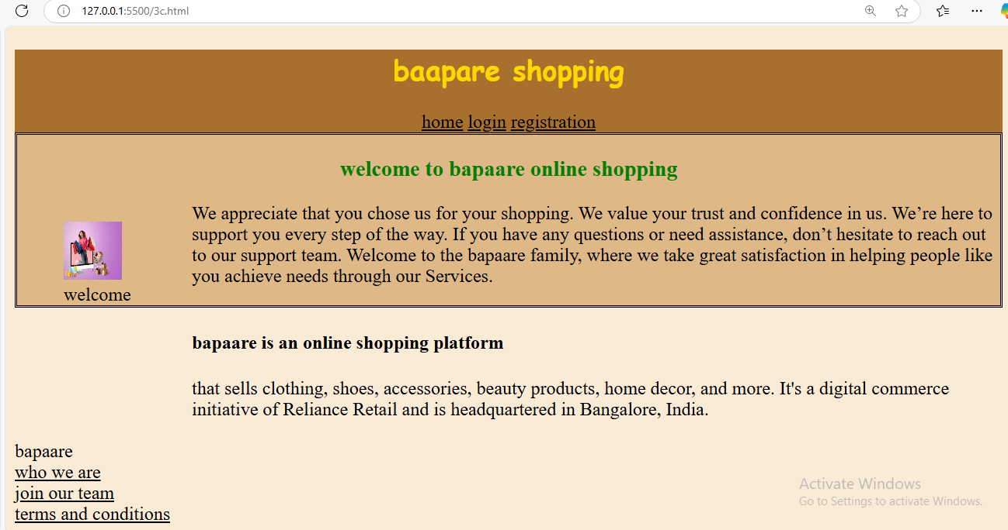

Experiment:4 Selector forms

4a. Write a program to apply simple selector forms

i.using element selector

**Source code:**

<!-- write a html program to apply selector forms -->

<!doctype html>

<html>

    <haed></haed>

    <style>

           h1{

        color:red;

        background-color: yellow;;

    }

    </style>

    <body>

        <h1 id="parag">

            <p class="pa">this is cseb section</p>

            <p>cseb section is this</p>

            <p >where is csebsection</p>

            <p>how is cseb scetion</p>

        </h1>

        <pre >what about cseb</pre>

        <pre >is it fine otr not</pre>

        <h2>welcome</h2>

        <p class="pa" >hello</p>

    </body>

</html>

Output:

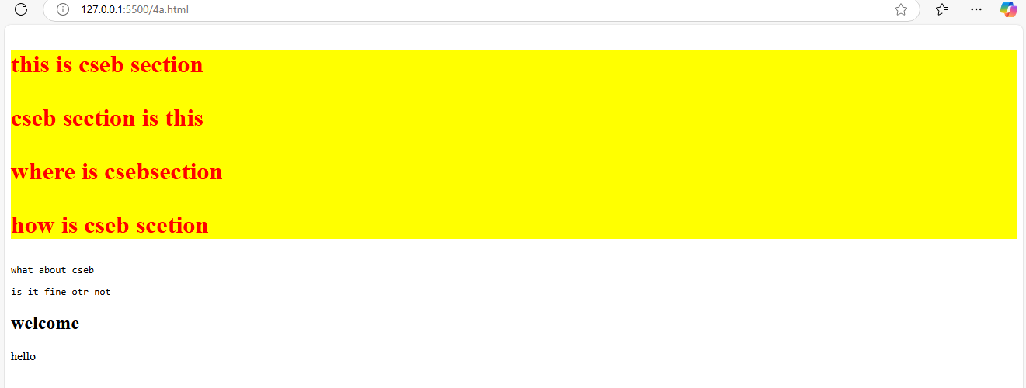

ii. id selector

**Source code:**

<!-- write a html program to apply selector forms -->

<!doctype html>

<html>

    <haed></haed>

    <style>

     /* id element style */

#parag{

        color:indigo;

        background-color: goldenrod;

     }

    </style>

    <body>

        <h1 id="parag">

            <p class="pa">this is cseb section</p>

            <p>cseb section is this</p>

            <p >where is csebsection</p>

            <p>how is cseb scetion</p>

        </h1>

        <pre >what about cseb</pre>

        <pre >is it fine otr not</pre>

        <h2>welcome</h2>

        <p class="pa" >hello</p>

    </body>

</html>

Output:

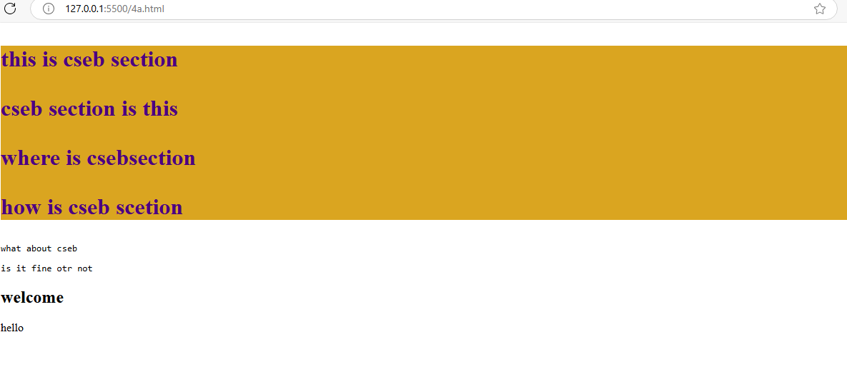

iii. using class selector

**Source code:**

<!-- write a html program to apply selector forms -->

<!doctype html>

<html>

    <haed></haed>

    <style>

     /* class element style */

     .pa{

        color:blue;

        background-color: antiquewhite;

     }

    </style>

    <body>

        <h1 id="parag">

            <p class="pa">this is cseb section</p>

            <p>cseb section is this</p>

            <p >where is csebsection</p>

            <p>how is cseb scetion</p>

        </h1>

        <pre >what about cseb</pre>

        <pre >is it fine otr not</pre>

        <h2>welcome</h2>

        <p class="pa" >hello</p>

    </body>

</html>

Output:

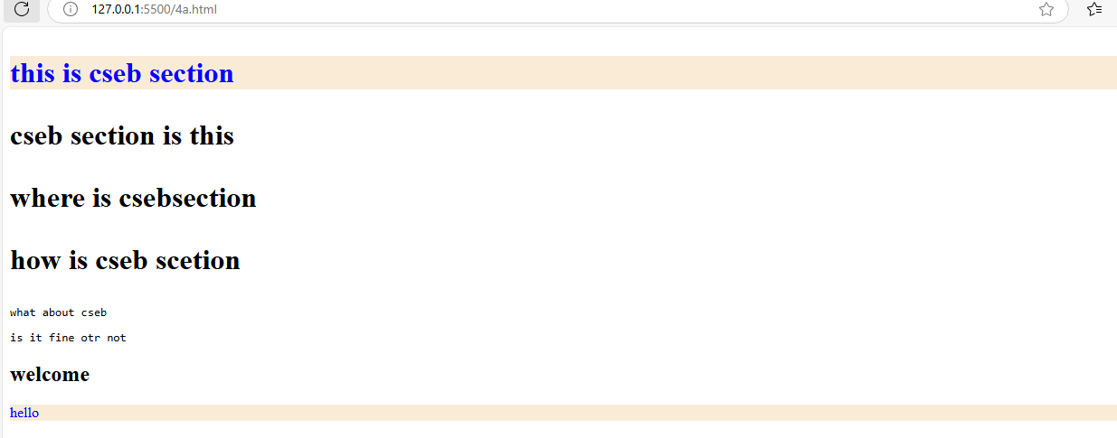

iv. using group selector

**Source code:**

<!-- write a html program to apply selector forms -->

<!doctype html>

<html>

    <haed></haed>

    <style>

/* group selector */

     h2,pre{

        color:aqua;

        background-color: black;

     }

    </style>

    <body>

        <h1 id="parag">

            <p class="pa">this is cseb section</p>

            <p>cseb section is this</p>

            <p >where is csebsection</p>

            <p>how is cseb scetion</p>

        </h1>

        <pre >what about cseb</pre>

        <pre >is it fine otr not</pre>

        <h2>welcome</h2>

        <p class="pa" >hello</p>

    </body>

</html>

Output:

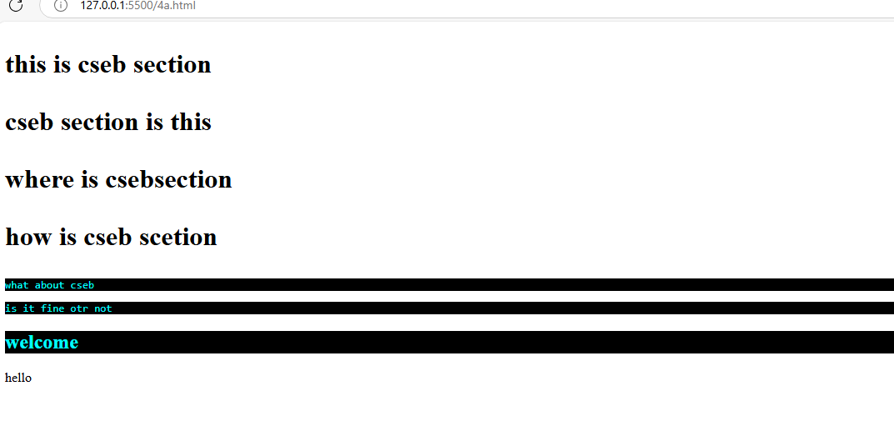

v.using universal selector

**Source code:**

<!-- write a html program to apply selector forms -->

<!doctype html>

<html>

    <haed></haed>

    <style>

/* universal selector */

     *{

        color:green;

        background-color: chocolate;

     }

    </style>

    <body>

        <h1 id="parag">

            <p class="pa">this is cseb section</p>

            <p>cseb section is this</p>

            <p >where is csebsection</p>

            <p>how is cseb scetion</p>

        </h1>

        <pre >what about cseb</pre>

        <pre >is it fine otr not</pre>

        <h2>welcome</h2>

        <p class="pa" >hello</p>

    </body>

</html>

Output:

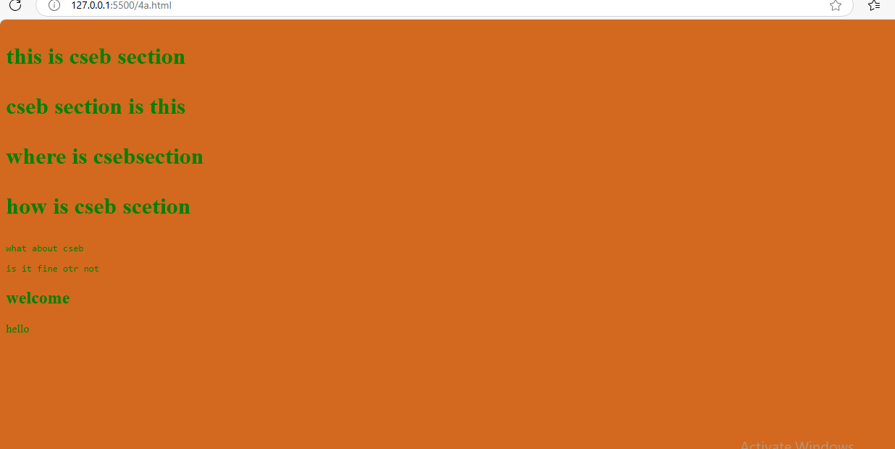

4b. Write a program to apply Combinator selector

i.using Descendant selector

**source code:**

<!DOCTYPE html>

<html>

    <head></head>

     <style>

        /* descending style */

        /* applyied color to the all the childs of the parent */

      div p{

        color:greenyellow;

      }

</style>

    <body>

       <div>

            <h3>A CSS combinator is used to specify the relationship between two CSS selectors. There are four different combinators in CSS:</h3>

            <p>Descendant combinator (space): Selects an element that is a descendant of another element.</p>

            <p>The descendant combinator matches all elements that are descendants of a specified element.</p>

            <section>

                <pre>descendant combinator</pre>

                <p>descendant combinator is the one of the combinator</p>

            </section>

        </div>

    </body>

</html>

**Output:**

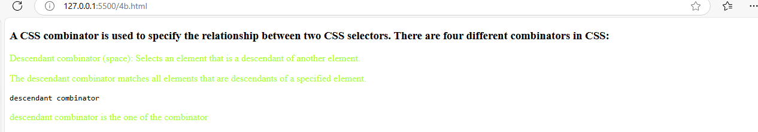

ii.using child selector

**source code:**

<!DOCTYPE html>

<html>

    <head></head>

     <style>

       /* child seelctor forms */

      /* apply styles to dirct childerens of the parent */

      div>p{

        color:red;

      }

</style>

    <body>

       <div>

            <h3>A CSS combinator is used to specify the relationship between two CSS selectors. There are four different combinators in CSS:</h3>

            <p>Child combinator (> or empty space): Selects an element that is a direct child of another element.</p>

            <p>TThe child combinator selects all elements that are the children of a specified element.</p>

            <section>

                <pre>descendant combinator</pre>

                <p>it is not direct child</p>

            </section>

        </div>

    </body>

</html>

Output:

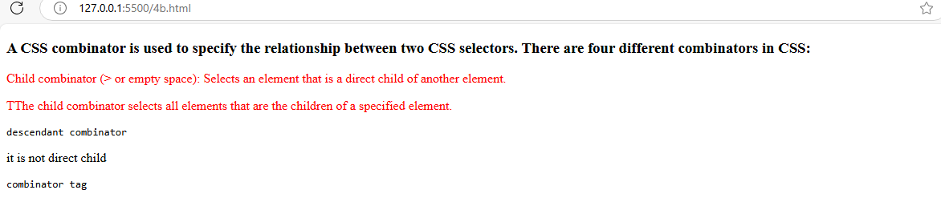

iii.using adjacent sibling selector

**source code:**

<!DOCTYPE html>

<html>

    <head></head>

     <style>

       /* adjacent sibling selector

      direct first nextsibling of child sto apply */

      article+p{

        color:blueviolet;

      }

</style>

    <body>

       <div>

            <h3>A CSS combinator is used to specify the relationship between two CSS selectors. There are four different combinators in CSS:</h3>

            <p>Child combinator (> or empty space): Selects an element that is a direct child of another element.</p>

            <p>TThe child combinator selects all elements that are the children of a specified element.</p>

            <section>

                <pre>descendant combinator</pre>

                <p>it is not direct child</p>

            </section>

        </div>

        <pre>combinator tag</pre>

        <article>

            <p>adjacent selector</p>

            <p>The next sibling combinator is used to select an element that is directly after another specific element.</p>

        </article>

        <p>Sibling elements must have the same parent element, and "adjacent" means "immediately following".</p>

        <p>these arethe siblings after the artcle</p>

    </body>

</html>

Output:

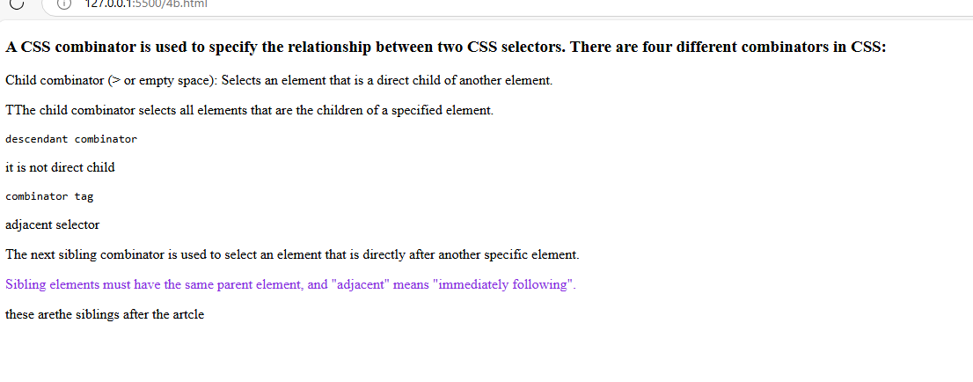

iv.using general sibling selector

**source code:**

<!DOCTYPE html>

<html>

    <head></head>

<style>

/* general sibling selector

      using tilled sysmbol and styles applied to all sibling after parent element */

      article~p{

        color:burlywood;

      }

</style>

<body>

        <div>

            <h3>A CSS combinator is used to specify the relationship between two CSS selectors. There are four different combinators in CSS:</h3>

            <p>Child combinator (> or empty space): Selects an element that is a direct child of another element.</p>

            <p>TThe child combinator selects all elements that are the children of a specified element.</p>

            <section>

                <pre>descendant combinator</pre>

                <p>it is not direct child</p>

            </section>

        </div>

        <pre>combinator tag</pre>

        <article>

            <p>adjacent selector</p>

            <p>The next sibling combinator is used to select an element that is directly after another specific element.</p>

        </article>

        <p>Sibling elements must have the same parent element, and "adjacent" means "immediately following".</p>

        <p>these arethe siblings after the artcle</p>

        </body>

</html>

Output:

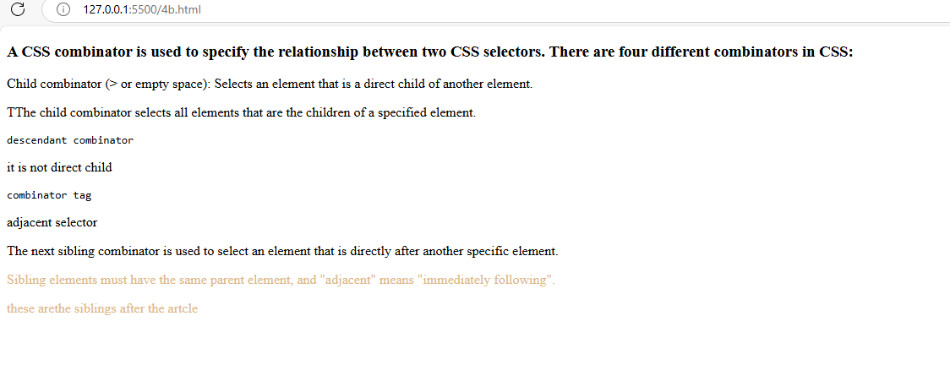

4c. Write a program to apply pseudo class selector

**Source code:**

<!doctype html>

 <html>

    <head></head>

    <style>

    a:link{

        color:brown;

        background-color: grey;

    }

    a:hover{

        color:white;

        background-color: green;

    }

    </style>

    <body>

        <h1>bapaare online shopping</h1>

        <a href="#" target="_parent">home</a>

        <a href="#" target="_parent">login</a>

        <a href="#" target="_parent">register</a>

        <p>A CSS pseudo-class is a keyword added to a selector that specifies a special state of the selected element. For example, the pseudo-class :hover can be used to select a button when a user's pointer hovers over the button, allowing you to style it accordingly</p>

    </body>

 </html>

Output:

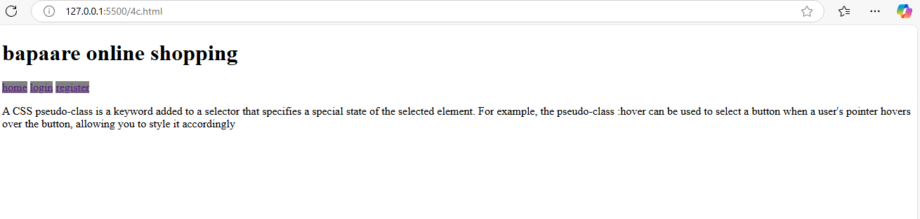

4d. Write a program to apply pseudo element selector

**Source code:**

 <!doctype html>

 <html>

    <head></head>

     <style>

    h1::first-letter{

        color:red;

        text-transform: uppercase;

    }

    pre::first-line{

        color:green;

    }

    h1::before{

       content:" adding text at begining ";

    }

    h1::after{

       content:" adding text at ending ";

    }

    p::selection{

        background-color:grey;

        color:white;

    }

    </style>

    <body>

        <h1>bapaare online shopping</h1>

        <a href="#" target="_parent">home</a>

        <a href="#" target="_parent">login</a>

        <a href="#" target="_parent">register</a>

        <pre>A CSS pseudo-element is used to style specific parts of an element.

            For example, it can be used to:

            Style the first letter or line, of an element

            Insert content before or after an element

            Style the markers of list items

            Style the viewbox behind a dialog box

            </pre>

    </body>

 </html>

Output:

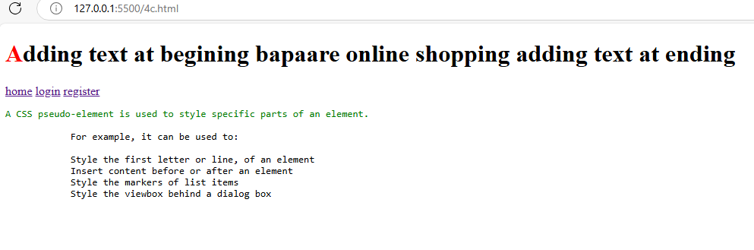

4e. Write a program to apply attribute selector

**Source code:**

 <!doctype html>

 <html>

    <head></head>

    <style>

        /* select all title attribute */

        [title]{

            border:5px solid yellow;

        }

        /* select exact value */

        [title='sacet cse dept']

        {

            color:white;

            background-color: aqua;

        }

        /* select any where matches the word */

        [title~="sacet"]

        {

            color:yellow;

            background-color: black;;

        }

        /* select when word comes at starting */

        [title^="sacp"]{

            color:green;

            background-color: blanchedalmond;

        }

        /* select word at end */

[title$="sacet"]{

    color:red;

    background-color: aqua;

}

    </style>

    <body>

        <img src="#" title="sacet cse dept" width="200" height="200">

        <br>

        <br>

        <img src="#" title="sacet ece dept" width="200" height="200">

        <img src="#" title="sacet eee dept" width="200" height="200">

        <img src="#" title="sacet mech dept" width="200" height="200">

        <img src="#" title="mech dept sacet" width="200" height="200">

        <img src="#" title="sacp pharma dept" width="200" height="200">

        <img src="#" title="sacp analysis dept" width="200" height="200">

    </body>

 </html>

**Output:**

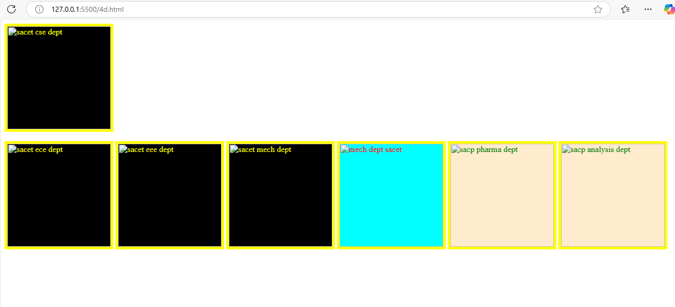

Experiment:5 CSS with Color, Background, Font, Text and CSS Box Model

5a. Write a program to demonstrate the various ways you can reference a color in CSS

**Source code:**

<!doctype html>

<html>

    <head></head>

    <style>

        #colorname{

            color:indianred;

            background-color: aqua;

        }

        #colorhex{

            color:#ffffff;

            background-color: #c24b90;

        }

        #colorrgb{

            color:rgb(10, 23, 50);

            background-color: rgb(55, 107, 107);

        }

        #colorrgba{

            color:rgb(29, 220, 39,1.0);

            background-color: rgb(242, 7, 117);

        }

        #colorothers{

            color:hwb(0 36% 20%);

            background-color: aqua;

        }

    </style>

    <body>

        <p id="colorname">to apply the colors in css we can use by their colorname</p>

        <p id="colorhex">to apply the colors to the content you can use hex decimal values</p>

        <p id="colorrgb">to aplly the colors to the content you can use the rgb values</p>

        <p id="colorrgba">to apply the colors to the content through the rgba</p>

        <p id="colorothers">to apply the coltrs to the content in otherways</p>

    </body>

</html>

Output:

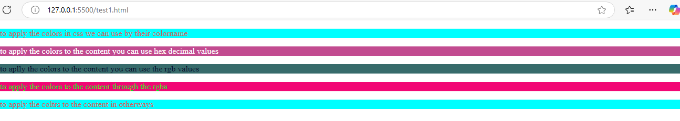

c. Write a program using the following terms related to CSS font and text: i. font-size ii. font-weight iii. font-style iv. text-decoration v. text-transformation vi. text-alignment

**source code:**

<!doctype html>

<html>

    <head></head>

    <style>

        #colorname{

            color:indianred;

            background-color: aqua;

        }

        #colorhex{

            color:#ffffff;

            background-color: #c24b90;

        }

        #colorrgb{

            color:rgb(10, 23, 50);

            background-color: rgb(55, 107, 107);

        }

        #colorrgba{

            color:rgb(29, 220, 39,1.0);

            background-color: rgb(242, 7, 117);

        }

        #colorothers{

            color:hwb(0 36% 20%);

            background-color: aqua;

        }

         p{

            font-size: 40px;

            font-weight: bold;

            font-style:italic;

            text-decoration: underline;

            text-transform: uppercase;

            text-align: center;

        }

    </style>

    <body>

        <p id="colorname">to apply the colors in css we can use by their colorname</p>

        <p id="colorhex">to apply the colors to the content you can use hex decimal values</p>

        <p id="colorrgb">to aplly the colors to the content you can use the rgb values</p>

        <p id="colorrgba">to apply the colors to the content through the rgba</p>

        <p id="colorothers">to apply the coltrs to the content in otherways</p>

    </body>

</html>

Output:

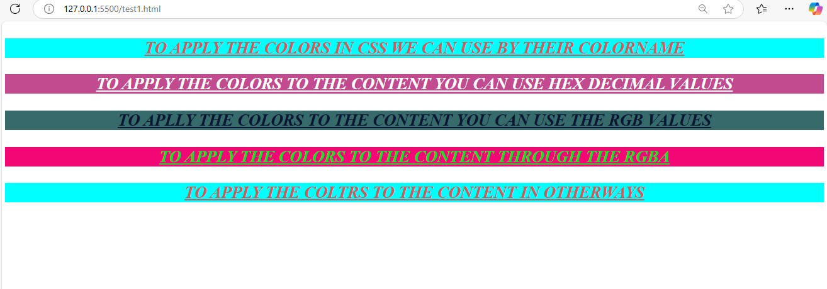

d. Write a program, to explain the importance of CSS Box model using

i. Content ii. Border iii. Margin iv. Padding

**source code:**

<!doctype html>

<html>

    <head></head>

    <style>

        #colorname{

            color:indianred;

            background-color: aqua;

        }

        #colorhex{

            color:#ffffff;

            background-color: #c24b90;

        }

        #colorrgb{

            color:rgb(10, 23, 50);

            background-color: rgb(55, 107, 107);

        }

        #colorrgba{

            color:rgb(29, 220, 39,1.0);

            background-color: rgb(242, 7, 117);

        }

        #colorothers{

            color:hwb(0 36% 20%);

            background-color: aqua;

        }

         p{

            padding:20px;

            margin:100px;

            border:2px solid red;

        }

    </style>

    <body>

        <p id="colorname">to apply the colors in css we can use by their colorname</p>

        <p id="colorhex">to apply the colors to the content you can use hex decimal values</p>

        <p id="colorrgb">to aplly the colors to the content you can use the rgb values</p>

        <p id="colorrgba">to apply the colors to the content through the rgba</p>

        <p id="colorothers">to apply the coltrs to the content in otherways</p>

    </body>

</html>

**Output:**

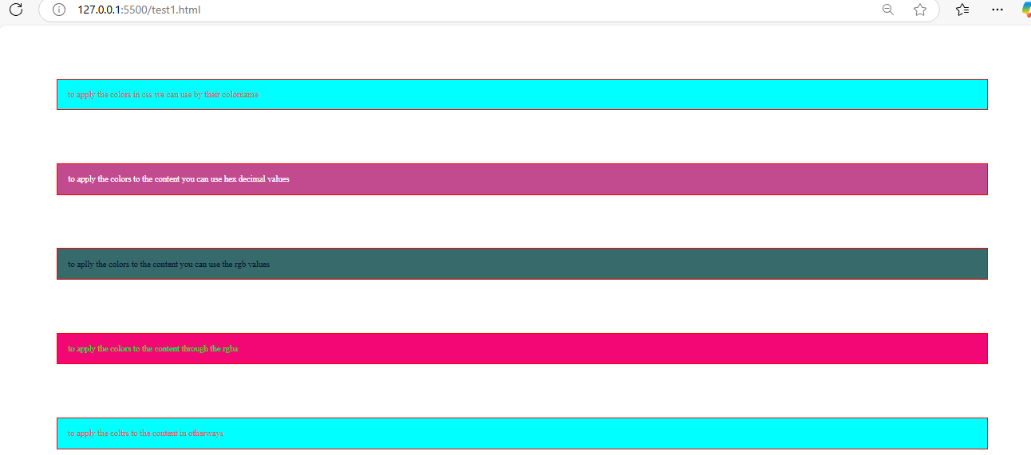

b. Write a CSS rule that places a background image halfway down the page, tilting it horizontally. The image should remain in place when the user scrolls up or down.

**Source code:**

<!doctype html>

<html>

    <head></head>

    <style>

        #colorname{

            color:indianred;

            background-color: aqua;

        }

        #colorhex{

            color:#ffffff;

            background-color: #c24b90;

        }

        #colorrgb{

            color:rgb(10, 23, 50);

            background-color: rgb(55, 107, 107);

        }

        #colorrgba{

            color:rgb(29, 220, 39,1.0);

            background-color: rgb(242, 7, 117);

        }

        #colorothers{

            color:hwb(0 36% 20%);

            background-color: aqua;

        }

         p{

            padding:20px;

            margin:100px;

            border:2px solid red;

            font-size: 40px;

            font-weight: bold;

            font-style:italic;

            text-decoration: underline;

            text-transform: uppercase;

            text-align: center;

        }

        body{

            background-image: url('gmg.jpg');

            background-repeat: no-repeat;

            background-size: cover;

            background-position: center 50%;

            background-attachment: fixed;

            transform: rotate(30deg);

        }

    </style>

    <body>

        <p id="colorname">to apply the colors in css we can use by their colorname</p>

        <p id="colorhex">to apply the colors to the content you can use hex decimal values</p>

        <p id="colorrgb">to aplly the colors to the content you can use the rgb values</p>

        <p id="colorrgba">to apply the colors to the content through the rgba</p>

        <p id="colorothers">to apply the coltrs to the content in otherways</p>

    </body></html>

**Output:**

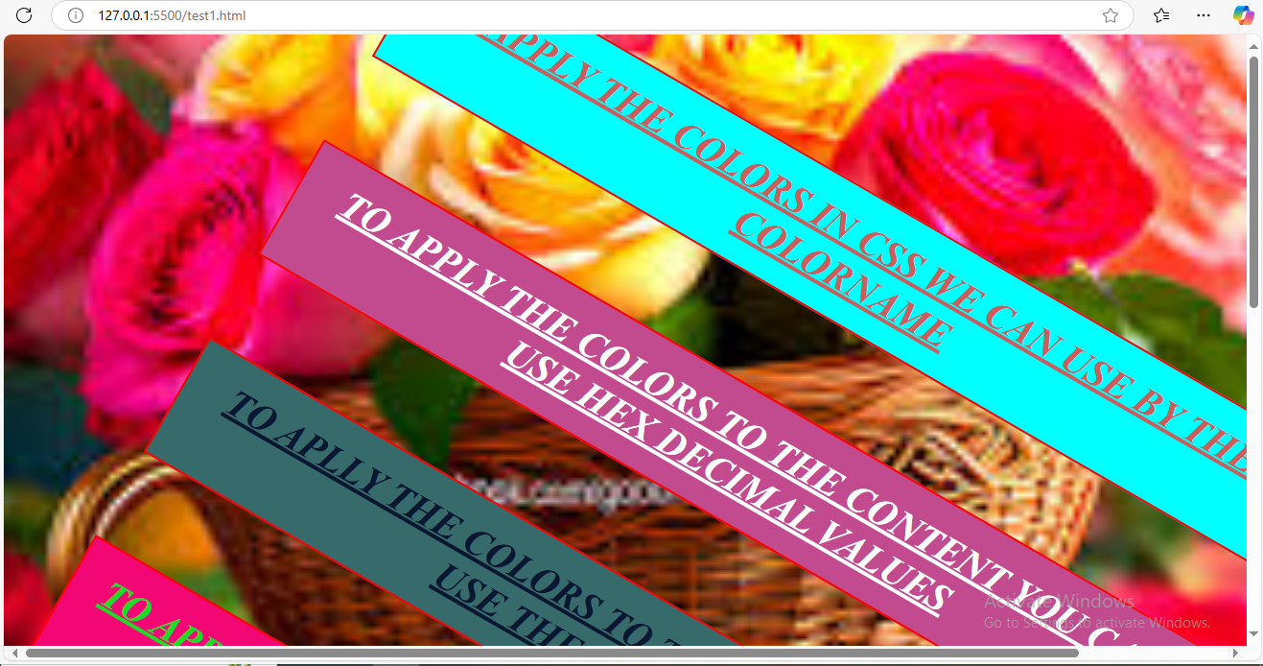

**Javascript:**

* JavaScript is a **scripting or programming language** that enables you to create dynamically updating content, control multimedia, animate images, and much more on web pages.
* It is an essential part of web development, standard web technologies, alongside HTML and CSS.
* Html is to define the content or structure of the web pages.
* Css is to specify the styles or layouts of the web pages.
* Java script is to provide the behavior of the web pages.
* Web browsers have a dedicated JavaScript engine that executes the client code..
* The most popular runtime system for non-browser usage is Node.js.

**Key Features**

* **Dynamic Content Updates**: JavaScript can update and change both HTML and CSS, allowing for interactive and responsive web pages
* **Event Handling**: It can respond to user actions like button clicks, form submissions, and other events
* **APIs**: JavaScript can interact with various APIs to perform tasks like retrieving geographical information, creating 2D/3D graphics, and handling multimedia.
* **Adding interactive to websites**
* **Developing mobile applications**
* **Create web browser based games.**
* **Backend web development.**

Experiment:6

Applying JavaScript - internal and external, I/O, Type Conversion

1. Write a program to embed internal and external JavaScript in a web page.

* Internal and External JavaScript are the two ways of adding JavaScript code to an HTML document.
* External JavaScript refers to adding JavaScript code in HTML from a separate .js file using the src attribute of <script> tag.
* Internal JavaScript refers to embedding JavaScript code directly within the HTML file using [<script> tag](https://www.geeksforgeeks.org/html-script-tag/), either inside the [<head>](https://www.geeksforgeeks.org/html-head-tag/)or [<body>](https://www.geeksforgeeks.org/html-body-tag/)tag. This method is useful for small scripts specific to a single page.

**Source code:**

<!DOCTYPE html>

<html>

    <head>

        <title>java script intro</title>

    </head>

//external javascript

    <script src="samplejs.js"></script>

    <body>

        <p>

            Internal and External JavaScript are the two ways of adding JavaScript code to an HTML document.

        </p>

        <p>

            External JavaScript refers to adding JavaScript code in HTML from a separate .js file using the src attribute of script tag.

        </p>

//internal javascript

        <script>

            document.write("welcome to internal java script");

            document.write("Internal JavaScript refers to embedding JavaScript code directly within the HTML file using script tag, either inside the head or body tag. This method is useful for small scripts specific to a single page.");

        </script>

    </body>

</html>

Sample.js:

document.write("welcome to external java script");

output:

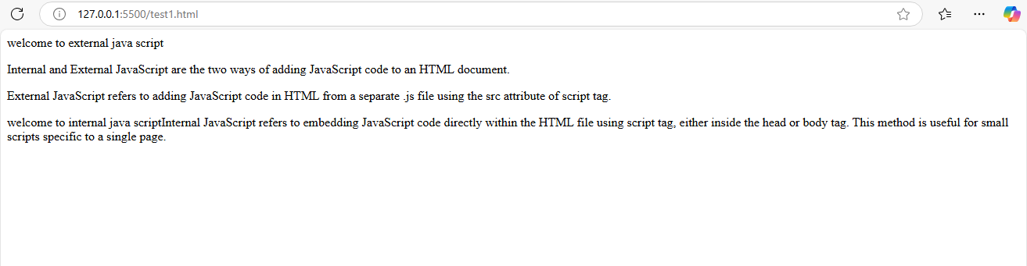

1. Write a program to explain the different ways for displaying output.

* There are 4 ways to display the output in JavaScript.
* Displaying the output in html elements using innerhtml attribute.
* Displaying the output using document.write().
* Displaying the output through console.log().
* Displaying the output through the alert box.

Source code:

<!DOCTYPE html>

<html>

    <head>

        <title>java script intro</title>

    </head>

    <body>

       <p>There are 4 ways to display the output in JavaScript.</p>

       <ol>

        <li>Displaying the output in html elements using innerhtml attribute.</li>

        <li>Displaying the output using document.write().</li>

        <li>Displaying the output using console.log().</li>

        <li>Displaying the output using alert box.</li>

       </ol>

       <p id="display"></p>

        <script>

            document.getElementById("display").innerHTML = "display output by element";

            alert("welcome to internal java script");

            document.write("Internal JavaScript refers to embedding JavaScript code directly within the HTML file using script tag, either inside the head or body tag. This method is useful for small scripts specific to a single page.");

        </script>

    </body>

</html>

Console.js

console.log("get output by console/terminal");

output:

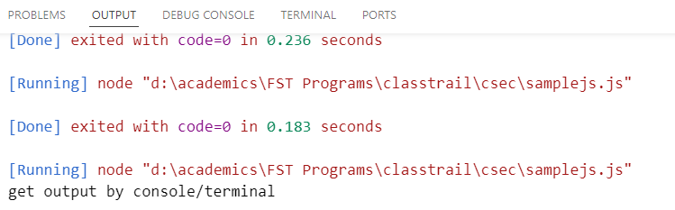

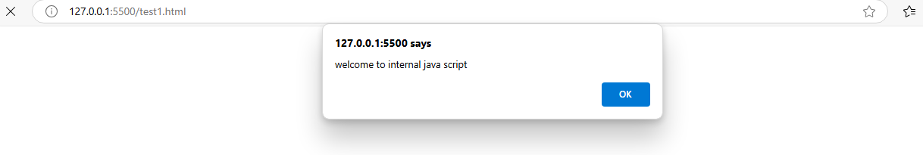

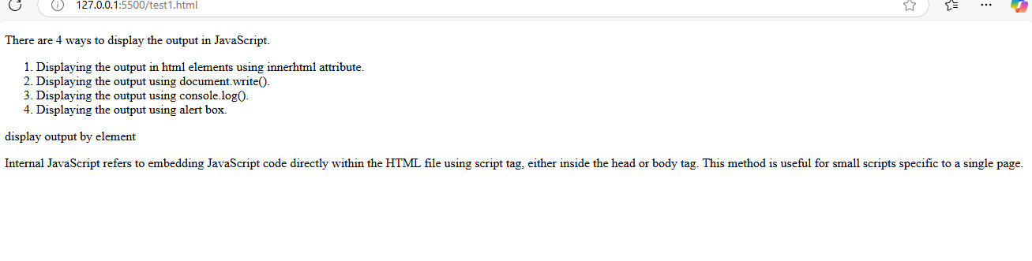

1. Write a program to explain the different ways for taking input.

Source code:

<!DOCTYPE html>

<head>

       <title>JavaScript Input Methods</title>

</head>

<body>

    <h1>JavaScript Input Methods</h1>

    <button onclick="usePrompt()">Take Input using Prompt</button>

    <button onclick="useConfirm()">Take Input using Confirm</button>

    <br><br>

    <!-- Input field -->

    <label for="userInput">Enter your name: </label>

    <input type="text" id="userInput" placeholder="Type something">

    <button onclick="getInputValue()">Submit</button>

    <p id="output"></p>

    <script>

        // 1. Taking input using prompt()

        function usePrompt() {

            let name = prompt("Enter your name:");

            if (name) {

                document.getElementById("output").innerHTML = "You entered: " + name;

            } else {

                document.getElementById("output").innerHTML = "You did not enter anything.";

            }

        }

        // 2. Taking input using an HTML input field

        function getInputValue() {

            let inputValue = document.getElementById("userInput").value;

            document.getElementById("output").innerHTML = "Input value: " + inputValue;

        }

        // 3. Taking input using confirm()

        function useConfirm() {

            let response = confirm("Do you like JavaScript?");

            if (response) {

                document.getElementById("output").innerHTML = "You clicked OK! ";

            } else {

                document.getElementById("output").innerHTML = "You clicked Cancel. ";

            }

        }

    </script>

</body>

</html>

Output:

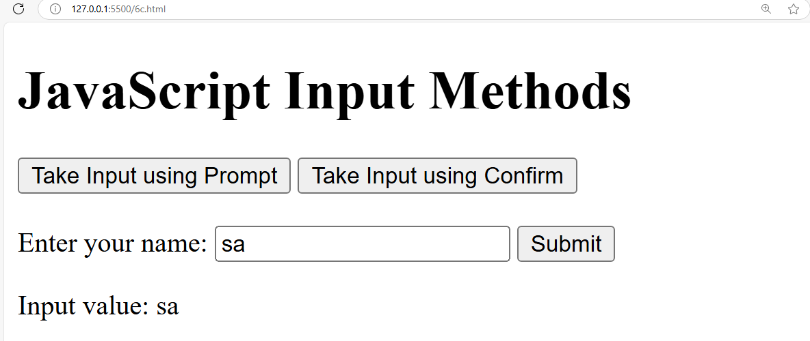

d. Create a webpage which uses prompt dialogue box to ask a voter for his name and age. Display the information in table format along with either the voter can vote or not.

Source code:

<!DOCTYPE html>

<head>

    <title>Voter Eligibility Check</title>

    <style>

        body {

            font-family: Arial, sans-serif;

            text-align: center;

            margin: 50px;

        }

        table {

            margin: 20px auto;

            border-collapse: collapse;

            width: 50%;

        }

        th, td {

            border: 1px solid black;

            padding: 10px;

            text-align: center;

        }

        th {

            background-color: #f2f2f2;

        }

    </style>

</head>

<body>

    <h1>Voter Eligibility Checker</h1>

    <script>

        // Ask user for Name and Age

        let name = prompt("Enter your name:");

        let age = prompt("Enter your age:");

        // Convert age to number

        age = Number(age);

        // Determine voter eligibility

        let eligibility = (age >= 18) ? "Eligible to Vote " : "Not Eligible to Vote ";

        // Display the result in a table format

        if (name && !isNaN(age)) {

            document.write(`

                <table>

                    <tr>

                        <th>Name</th>

                        <th>Age</th>

                        <th>Voting Eligibility</th>

                    </tr>

                    <tr>

                        <td>${name}</td>

                        <td>${age}</td>

                        <td>${eligibility}</td>

                    </tr>

                </table>

            `);

        } else {

            document.write("<p style='color:red;'>Invalid input. Please refresh and enter valid details.</p>");

        }

    </script>

</body>

</html>

Output:

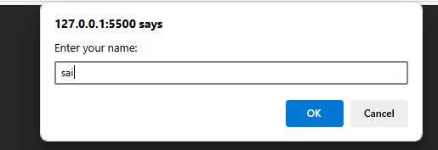

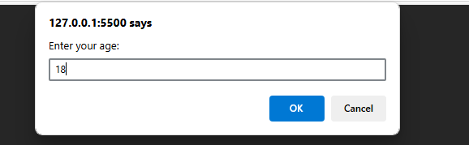

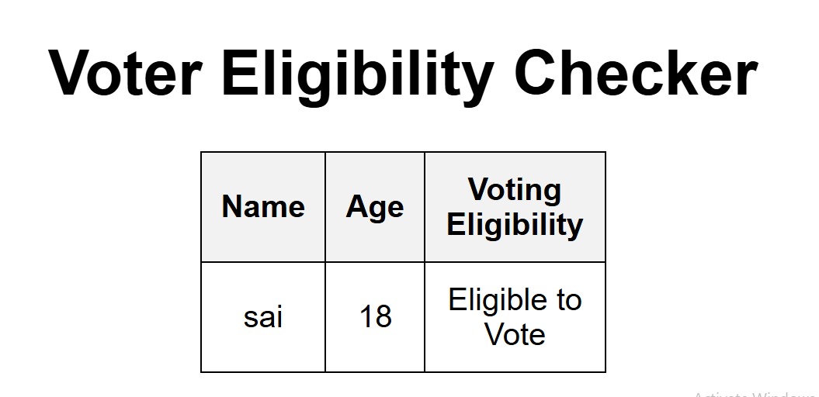

Output2:

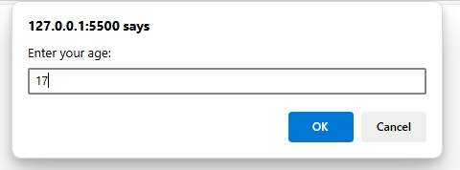

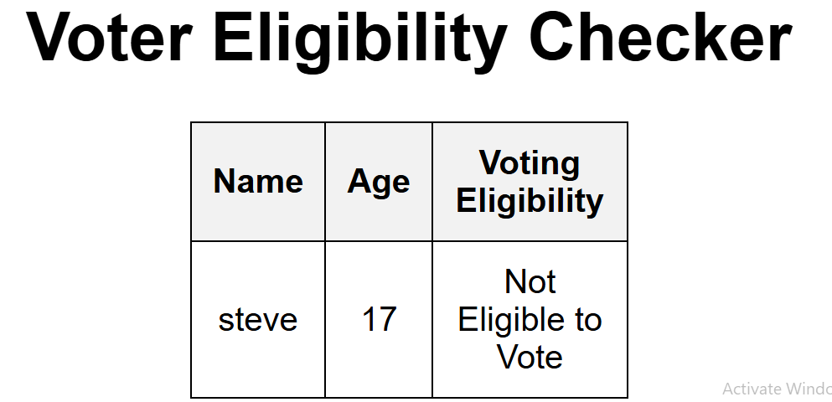

Experiment:7

Java Script Pre-defined and User-defined Objects

1. Write a program using document object properties and methods.

Source code:

<!DOCTYPE html>

<head>

  <title>My College - Student Details-7a</title>

  <script>

    // User-defined object constructor for Student

    function Student(name, id, branch) {

      this.name = name;

      this.id = id;

      this.branch = branch;

      // Method to display student details using document methods

      this.displayDetails = function() {

        // Create a div element to hold the student details

        var studentDiv = document.createElement('div');

        studentDiv.innerHTML = '<h2>Student Details</h2>' +

                               '<p><strong>Name:</strong> ' + this.name + '</p>' +

                               '<p><strong>ID:</strong> ' + this.id + '</p>' +

                               '<p><strong>Branch:</strong> ' + this.branch + '</p>';

        // Append the div to the body using the pre-defined document object

        document.body.appendChild(studentDiv);

      }

    }

    // Use window.onload to run code after the document is fully loaded

    window.onload = function() {

      // Create a header element using a document method

      var header = document.createElement('h1');

      header.textContent = 'My College - Student Details';

      document.body.appendChild(header);

      // Create an instance of the user-defined Student object

      var student1 = new Student("sai", "123", "Computer Science");

      // Call the method to display the student's details

      student1.displayDetails();

      // Create a paragraph element to provide additional information

      var infoPara = document.createElement('p');

      infoPara.textContent = 'For more information, visit admin department.';

      document.body.appendChild(infoPara);

    }

  </script>

</head>

<body>

</body>

</html>

Output:

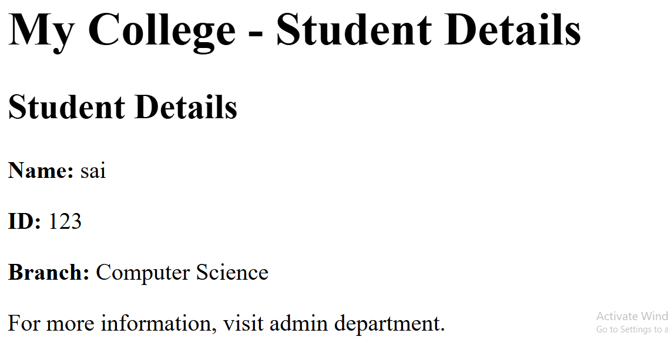

1. Write a program using window object properties and methods.

Source code:

<!DOCTYPE html>

<html>

<head>

  <title>My College - Student Details</title>

  <script>

    // User-defined object constructor for Student

    function Student(name, id, branch) {

      this.name = name;

      this.id = id;

      this.branch = branch;

      // Method to display student details using document methods

      this.displayDetails = function() {

        // Create a div element to hold the student details

        var studentDiv = document.createElement('div');

        studentDiv.innerHTML = '<h2>Student Details</h2>' +

                               '<p><strong>Name:</strong> ' + this.name + '</p>' +

                               '<p><strong>ID:</strong> ' + this.id + '</p>' +

                               '<p><strong>Branch:</strong> ' + this.branch + '</p>';

        // Append the div to the body using the pre-defined document object

        document.body.appendChild(studentDiv);

      }

    }

    // Use window.onload to run code after the document is fully loaded

    window.onload = function() {

      // Create a header element using a document method

      var header = document.createElement('h1');

      header.textContent = 'My College - Student Details';

      document.body.appendChild(header);

      // Create an instance of the user-defined Student object

      var student1 = new Student("Arjun", "A001", "Computer Science");

      // Call the method to display the student's details

      student1.displayDetails();

      // Create a paragraph element to provide additional information

      var infoPara = document.createElement('p');

      infoPara.textContent = 'For more information, visit admin department.';

      document.body.appendChild(infoPara);

      // ----- Demonstration of window object properties and methods -----

      // Display the current URL using window.location.href

      var urlPara = document.createElement('p');

      urlPara.textContent = 'Current URL: ' + window.location.href;

      document.body.appendChild(urlPara);

      // Create a button to display window dimensions using window.innerWidth and window.innerHeight

      var sizeButton = document.createElement('button');

      sizeButton.textContent = 'Show Window Size';

      sizeButton.onclick = function() {

        alert('Window Size - Width: ' + window.innerWidth + 'px, Height: ' + window.innerHeight + 'px');

      };

      document.body.appendChild(sizeButton);

      // Create another button that opens a new window using window.open()

      var newWindowButton = document.createElement('button');

      newWindowButton.textContent = 'Open New Window';

      newWindowButton.onclick = function() {

        // Open a new window with a simple HTML content

        var newWin = window.open("", "NewWindow", "width=400,height=300");

        newWin.document.write("<h2>Welcome to the new window!</h2><p>This window was opened using window.open()</p>");

      };

      document.body.appendChild(newWindowButton);

    }

  </script>

</head>

<body>

</body>

</html>

Output:

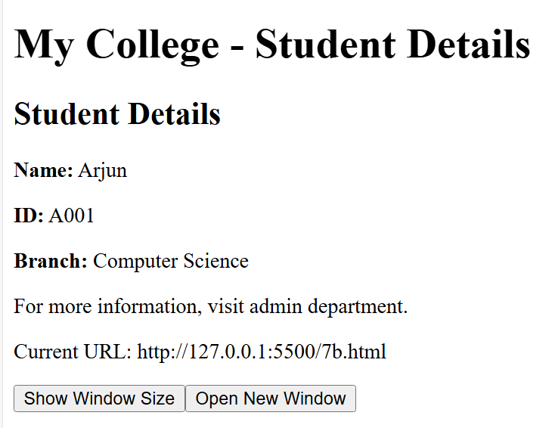

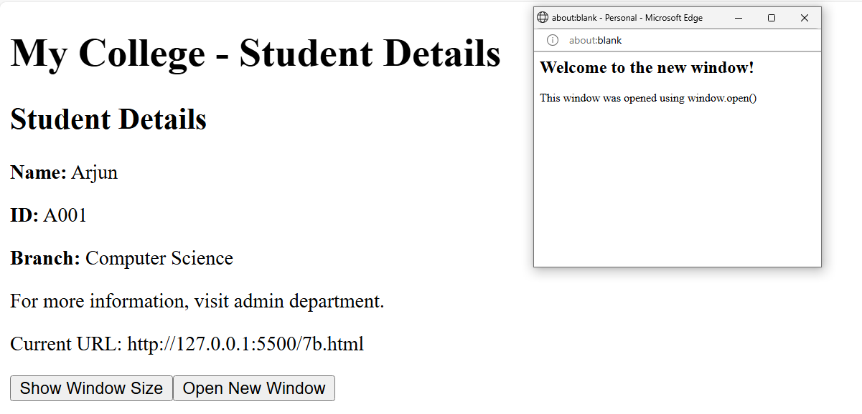

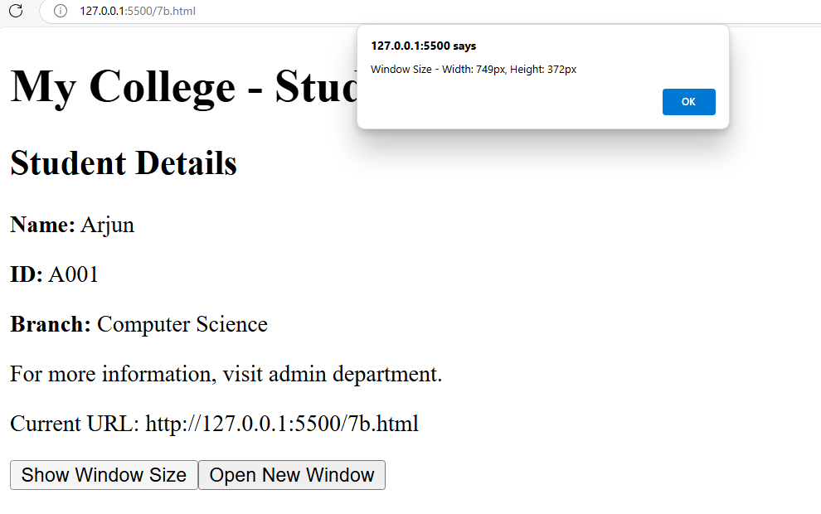

1. Write a program using array object properties and methods.

<!DOCTYPE html>

<html >

<head>

<title>My College - Student Details</title>

<script>

// User-defined object constructor for Student

function Student(name, id, branch) {

this.name = name;

this.id = id;

this.branch = branch;

// Method to display student details using document methods

this.displayDetails = function() {

// Create a div element to hold the student details

var studentDiv = document.createElement('div');

studentDiv.innerHTML = '<h2>Student Details</h2>' +

'<p><strong>Name:</strong> ' + this.name + '</p>' +

'<p><strong>ID:</strong> ' + this.id + '</p>' +

'<p><strong>Branch:</strong> ' + this.branch + '</p>';

// Append the div to the body using the pre-defined document object

document.body.appendChild(studentDiv);

}

}

// Use window.onload to run code after the document is fully loaded

window.onload = function() {

// Create a header element using a document method

var header = document.createElement('h1');

header.textContent = 'My College - Student Details';

document.body.appendChild(header);

// Create an instance of the user-defined Student object

var student1 = new Student("sai", "123", "Computer Science");

// Call the method to display the student's details

student1.displayDetails();

// Create a paragraph element to provide additional information

var infoPara = document.createElement('p');

infoPara.textContent = 'For more information, visit admin department.';

document.body.appendChild(infoPara);

// --------- Array Object Properties and Methods Demonstration ---------

// Section header for Array Operations

var arrayHeader = document.createElement('h2');

arrayHeader.textContent = 'Array Object Properties and Methods';

document.body.appendChild(arrayHeader);

// Initialize an array of student names

var studentNames = ["ramu", "seshu", "Romeo", "Priyanka"];

// Display the initial array using join()

var initialArrayPara = document.createElement('p');

initialArrayPara.textContent = 'Initial Array: ' + studentNames.join(", ");

document.body.appendChild(initialArrayPara);

// Display the length property of the array

var lengthPara = document.createElement('p');

lengthPara.textContent = 'Array Length: ' + studentNames.length;

document.body.appendChild(lengthPara);

// Add a new student name using the push() method

studentNames.push("Suresh");

var pushPara = document.createElement('p');

pushPara.textContent = 'After push("steveharris"): ' + studentNames.join(", ");

document.body.appendChild(pushPara);

// Remove the last element using the pop() method

var removedName = studentNames.pop();

var popPara = document.createElement('p');

popPara.textContent = 'After pop(), removed: ' + removedName + '. Array now: ' + studentNames.join(", ");

document.body.appendChild(popPara);

// Sort the array using the sort() method

studentNames.sort();

var sortPara = document.createElement('p');

sortPara.textContent = 'After sort(): ' + studentNames.join(", ");

document.body.appendChild(sortPara);

// Reverse the array using the reverse() method

studentNames.reverse();

var reversePara = document.createElement('p');

reversePara.textContent = 'After reverse(): ' + studentNames.join(", ");

document.body.appendChild(reversePara);

// Join array elements into a string using the join() method with a custom separator

var joinStr = studentNames.join(" - ");

var joinPara = document.createElement('p');

joinPara.textContent = 'Using join(" - "): ' + joinStr;

document.body.appendChild(joinPara);

}

</script>

</head>

<body>

</body>

</html>

Output:

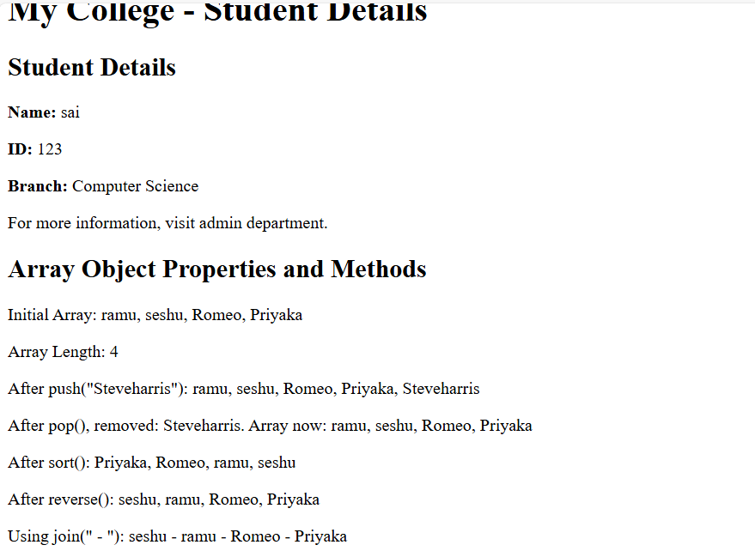

1. Write a program using math object properties and methods.

<!DOCTYPE html>

<html >

<head>

<title>My College - Student Details</title>

<script>

// User-defined object constructor for Student

function Student(name, branch, marks, totalMarks) {

this.name = name;

// Generate a random user id using Math.random() and Math.floor()

this.id = "A" + Math.floor(Math.random() * 1000);

this.branch = branch;

this.marks = marks;

this.totalMarks = totalMarks;

// Calculate percentage and round it to the nearest integer using Math.round()

this.percentage = Math.round((marks / totalMarks) * 100);

// Method to display student details using document methods

this.displayDetails = function() {

// Create a div element to hold the student details

var studentDiv = document.createElement('div');

studentDiv.innerHTML = '<h2>Student Details</h2>' +

'<p><strong>Name:</strong> ' + this.name + '</p>' +

'<p><strong>ID:</strong> ' + this.id + '</p>' +

'<p><strong>Branch:</strong> ' + this.branch + '</p>' +

'<p><strong>Marks:</strong> ' + this.marks + ' out of ' + this.totalMarks + '</p>' +

'<p><strong>Percentage:</strong> ' + this.percentage + '%</p>';

// Append the div to the body using the pre-defined document object

document.body.appendChild(studentDiv);

}

}

// Run code after the document is fully loaded

window.onload = function() {

// Create a header element using a document method

var header = document.createElement('h1');

header.textContent = 'My College - Student Details';

document.body.appendChild(header);

// Create an instance of the Student object

// Here, marks are 432 out of 500, and the percentage will be rounded

var student1 = new Student("steveharris", "Computer Science", 432, 500);

// Display the student's details

student1.displayDetails();

// Additional information regarding Math usage

var infoPara = document.createElement('p');

infoPara.textContent = 'Student details include a randomly generated ID and a rounded percentage computed using Math methods.';

document.body.appendChild(infoPara);

}

</script>

</head>

<body>

</body>

</html>

Output:

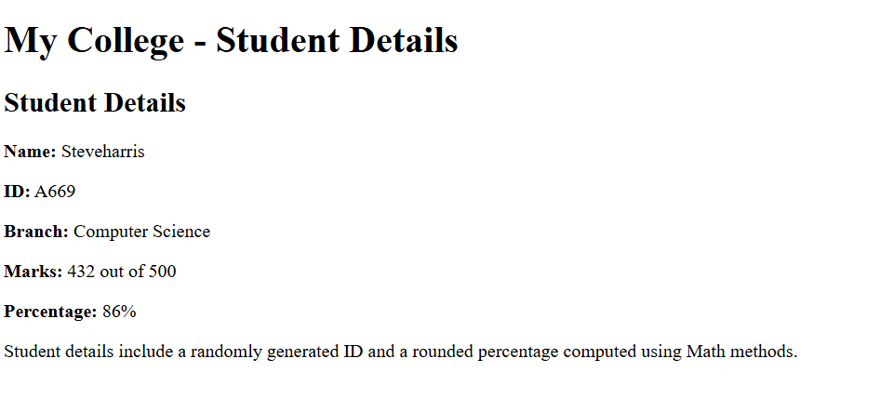

1. Write a program using string object properties and methods.

<!DOCTYPE html>

<html lang="en">

<head>

<meta charset="UTF-8">

<title>My College - Student Details</title>

<script>

// User-defined object constructor for Student

function Student(name, branch, marks, totalMarks) {

this.name = name;

// Generate a random user id using Math.random() and Math.floor()

this.id = "A" + Math.floor(Math.random() * 1000);

this.branch = branch;

this.marks = marks;

this.totalMarks = totalMarks;

// Calculate percentage and round it to the nearest integer using Math.round()

this.percentage = Math.round((marks / totalMarks) * 100);

// Method to display student details using document methods

this.displayDetails = function() {

// Create a div element to hold the student details

var studentDiv = document.createElement('div');

studentDiv.innerHTML = '<h2>Student Details</h2>' +

'<p><strong>Name:</strong> ' + this.name + '</p>' +

'<p><strong>ID:</strong> ' + this.id + '</p>' +

'<p><strong>Branch:</strong> ' + this.branch + '</p>' +

'<p><strong>Marks:</strong> ' + this.marks + ' out of ' + this.totalMarks + '</p>' +

'<p><strong>Percentage:</strong> ' + this.percentage + '%</p>';

// Append the div to the body using the pre-defined document object

document.body.appendChild(studentDiv);

}

}

// Run code after the document is fully loaded

window.onload = function() {

// Create a header element using a document method

var header = document.createElement('h1');

header.textContent = 'My College - Student Details';

document.body.appendChild(header);

// Create an instance of the Student object

// Here, marks are 432 out of 500, and the percentage will be rounded

var student1 = new Student("steveharris", "Computer Science", 432, 500);

// Display the student's details

student1.displayDetails();

// Additional information regarding String usage

var infoPara = document.createElement('p');

infoPara.textContent = 'This example demonstrates string object properties and methods applied to student details.';

document.body.appendChild(infoPara);

// --------- String Object Properties and Methods Demonstration ---------

// Section header for String Operations

var stringHeader = document.createElement('h2');

stringHeader.textContent = 'String Object Properties and Methods';

document.body.appendChild(stringHeader);

// Using the student name for various string operations

var nameStr = student1.name; // "Arjun Kumar"

// Display the length property of the string

var lengthPara = document.createElement('p');

lengthPara.textContent = 'Length of student name: ' + nameStr.length;

document.body.appendChild(lengthPara);

// Convert the string to uppercase

var upperPara = document.createElement('p');

upperPara.textContent = 'Uppercase: ' + nameStr.toUpperCase();

document.body.appendChild(upperPara);

// Convert the string to lowercase

var lowerPara = document.createElement('p');

lowerPara.textContent = 'Lowercase: ' + nameStr.toLowerCase();

document.body.appendChild(lowerPara);

// Extract a substring (first name) using substring() and indexOf()

var firstName = nameStr.substring(0, nameStr.indexOf(" "));

var substringPara = document.createElement('p');

substringPara.textContent = 'First Name (using substring): ' + firstName;

document.body.appendChild(substringPara);

// Find the index of the space character in the name using indexOf()

var indexPara = document.createElement('p');

indexPara.textContent = 'Index of space in name: ' + nameStr.indexOf(" ");

document.body.appendChild(indexPara);

// Split the full name into an array of words using split()

var splitName = nameStr.split(" ");

var splitPara = document.createElement('p');

splitPara.textContent = 'Split name (first and last): ' + splitName.join(" | ");

document.body.appendChild(splitPara);

// Display the first character of the name using charAt()

var charPara = document.createElement('p');

charPara.textContent = 'First character of the name: ' + nameStr.charAt(0);

document.body.appendChild(charPara);

}

</script>

</head>

<body>

</body>

</html>

Output:

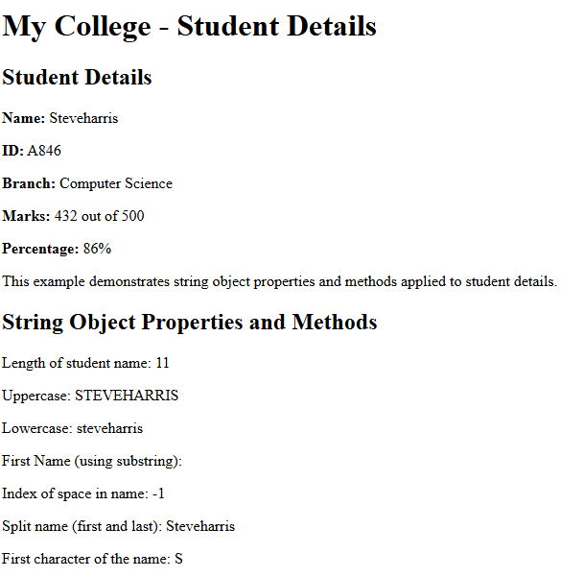

1. Write a program using regex object properties and methods.

<!DOCTYPE html>

<html lang="en">

<head>

<meta charset="UTF-8">

<title>My College - Student Details</title>

<script>

// User-defined object constructor for Student

function Student(name, branch) {

this.name = name;

// Generate a random user id using Math.random() and Math.floor()

this.id = "A" + Math.floor(Math.random() * 1000);

this.branch = branch;

// Method to display student details using document methods

this.displayDetails = function() {

// Create a div element to hold the student details

var studentDiv = document.createElement('div');

studentDiv.innerHTML = '<h2>Student Details</h2>' +

'<p><strong>Name:</strong> ' + this.name + '</p>' +

'<p><strong>ID:</strong> ' + this.id + '</p>' +

'<p><strong>Branch:</strong> ' + this.branch + '</p>';

// Append the div to the body using the document object

document.body.appendChild(studentDiv);

}

}

// Run code after the document is fully loaded

window.onload = function() {

// Create a header element using a document method

var header = document.createElement('h1');

header.textContent = 'My College - Student Details';

document.body.appendChild(header);

// Create an instance of the Student object (marks and percentage dropped)

var student1 = new Student("steveharris", "Computer Science");

student1.displayDetails();

// --------- Regex Object Properties and Methods Demonstration ---------

var regexHeader = document.createElement('h2');

regexHeader.textContent = 'Regex Object Properties and Methods';

document.body.appendChild(regexHeader);

// Define a regular expression to validate that the student's name contains only letters and spaces

var nameRegex = /^[A-Za-z\s]+$/;

// Use test() to check if the name matches the regex

var isNameValid = nameRegex.test(student1.name);

var testPara = document.createElement('p');

testPara.textContent = 'Using test(): The student name "' + student1.name + '" is ' + (isNameValid ? 'valid' : 'invalid') + '.';

document.body.appendChild(testPara);

// Use match() to extract the first word (first name) from the student name

var matchResult = student1.name.match(/[A-Z][a-z]+/);

var matchPara = document.createElement('p');

matchPara.textContent = 'Using match(): The first word in the name is "' + (matchResult ? matchResult[0] : 'Not Found') + '".';

document.body.appendChild(matchPara);

// Use search() to find the index of the first space in the student name

var searchIndex = student1.name.search(/\s/);

var searchPara = document.createElement('p');

searchPara.textContent = 'Using search(): The index of the first space in the name is ' + searchIndex + '.';

document.body.appendChild(searchPara);

// Use replace() to remove all spaces from the student name

var nameWithoutSpaces = student1.name.replace(/\s/g, "");

var replacePara = document.createElement('p');

replacePara.textContent = 'Using replace(): The name without spaces is "' + nameWithoutSpaces + '".';

document.body.appendChild(replacePara);

// Use exec() to execute a search for a match (similar to test but returns an array)

var execResult = nameRegex.exec(student1.name);

var execPara = document.createElement('p');

execPara.textContent = 'Using exec(): The result is ' + (execResult ? execResult[0] : 'null') + '.';

document.body.appendChild(execPara);

}

</script>

</head>

<body>

</body>

</html>

Output:

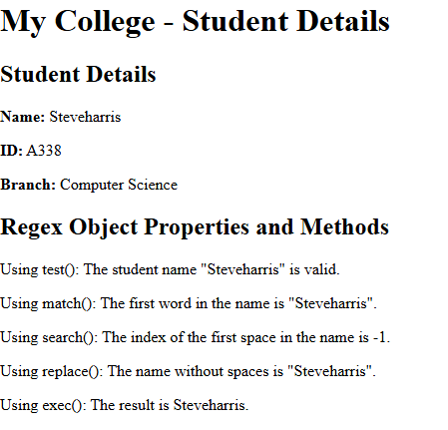

1. . Write a program using date object properties and methods.

<!DOCTYPE html>

<html lang="en">

<head>

<meta charset="UTF-8">

<title>My College - Student Details</title>

<script>

// User-defined object constructor for Student

function Student(name, branch, dob, joinYear) {

this.name = name;

// Generate a random user id using Math.random() and Math.floor()

this.id = "A" + Math.floor(Math.random() * 1000);

this.branch = branch;

// Store date of birth (as a Date object) and the year of joining

this.dob = new Date(dob); // dob should be in a format like "1999-03-15"

this.joinYear = joinYear;

// Calculate the age using the Date object

var today = new Date();

var age = today.getFullYear() - this.dob.getFullYear();

var m = today.getMonth() - this.dob.getMonth();

if (m < 0 || (m === 0 && today.getDate() < this.dob.getDate())) {

age--;

}

this.age = age;

// Method to display student details using document methods

this.displayDetails = function() {

var studentDiv = document.createElement('div');

studentDiv.innerHTML = '<h2>Student Details</h2>' +

'<p><strong>Name:</strong> ' + this.name + '</p>' +

'<p><strong>ID:</strong> ' + this.id + '</p>' +

'<p><strong>Branch:</strong> ' + this.branch + '</p>' +

'<p><strong>Date of Birth:</strong> ' + this.dob.toDateString() + '</p>' +

'<p><strong>Age:</strong> ' + this.age + '</p>' +

'<p><strong>Year of Joining:</strong> ' + this.joinYear + '</p>';

document.body.appendChild(studentDiv);

}

}

// Run code after the document is fully loaded

window.onload = function() {

// Create a header element using document methods

var header = document.createElement('h1');

header.textContent = 'My College - Student Details';

document.body.appendChild(header);

// Create an instance of the Student object with a date of birth and year of joining

var student1 = new Student("steveharris", "Computer Science", "1999-03-15", 2018);

student1.displayDetails();

// --------- Date Object Properties and Methods Demonstration ---------

var dateHeader = document.createElement('h2');

dateHeader.textContent = 'Date Object Properties and Methods';

document.body.appendChild(dateHeader);

// Create a Date object for the current date and time

var currentDate = new Date();

// Display the current date and time using toLocaleString()

var currentDatePara = document.createElement('p');

currentDatePara.textContent = 'Current Date and Time: ' + currentDate.toLocaleString();

document.body.appendChild(currentDatePara);

// Display individual properties of the current date

var currentYearPara = document.createElement('p');

currentYearPara.textContent = 'Current Year: ' + currentDate.getFullYear();

document.body.appendChild(currentYearPara);

var currentMonthPara = document.createElement('p');

// getMonth() returns month index (0-11), add 1 for human-readable format

currentMonthPara.textContent = 'Current Month: ' + (currentDate.getMonth() + 1);

document.body.appendChild(currentMonthPara);

var currentDayPara = document.createElement('p');

currentDayPara.textContent = 'Current Day: ' + currentDate.getDate();

document.body.appendChild(currentDayPara);

var currentHoursPara = document.createElement('p');

currentHoursPara.textContent = 'Current Hour: ' + currentDate.getHours();

document.body.appendChild(currentHoursPara);

var currentMinutesPara = document.createElement('p');

currentMinutesPara.textContent = 'Current Minutes: ' + currentDate.getMinutes();

document.body.appendChild(currentMinutesPara);

var currentSecondsPara = document.createElement('p');

currentSecondsPara.textContent = 'Current Seconds: ' + currentDate.getSeconds();

document.body.appendChild(currentSecondsPara);

}

</script>

</head>

<body>

</body>

</html>

Output:

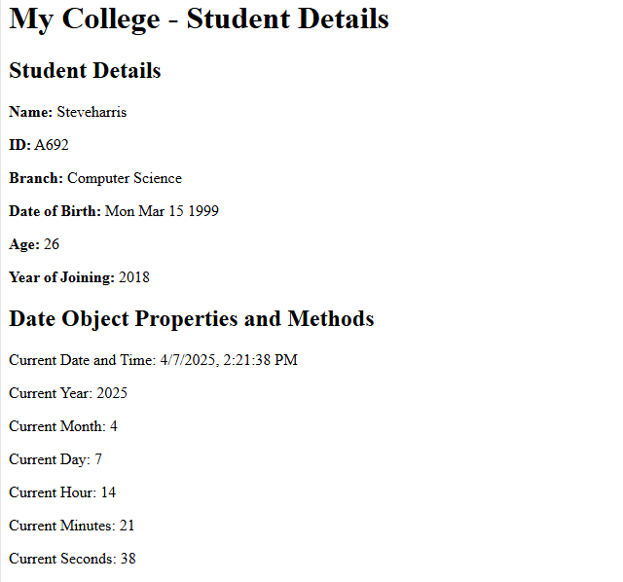

1. Write a program to explain user-defined object by using properties, methods, accessors,constructors and display.

<!DOCTYPE html>

<html>

<head>

<title>My College - Student Details</title>

<script>

// User-defined object constructor for Student

function Student(firstName, lastName, branch) {

// Properties

this.firstName = firstName;

this.lastName = lastName;

this.branch = branch;

// Generate a random user ID using Math.random() and Math.floor()

this.id = "A" + Math.floor(Math.random() * 1000);

// Accessor: Define a getter and setter for fullName

Object.defineProperty(this, 'fullName', {

get: function() {

return this.firstName + " " + this.lastName;

},

set: function(name) {

var parts = name.split(" ");

this.firstName = parts[0];

this.lastName = parts[1] || "";

},

enumerable: true,

configurable: true

});

// Method: Display student details on the page using document methods

this.displayDetails = function() {

var studentDiv = document.createElement('div');

studentDiv.innerHTML = '<h2>Student Details</h2>' +

'<p><strong>ID:</strong> ' + this.id + '</p>' +

'<p><strong>Full Name:</strong> ' + this.fullName + '</p>' +

'<p><strong>Branch:</strong> ' + this.branch + '</p>';

document.body.appendChild(studentDiv);

}

}

// Run the code after the document is fully loaded

window.onload = function() {

// Create an instance of the Student object using the constructor

var student1 = new Student("steve", "harris", "Computer Science");

// Display the student details initially

student1.displayDetails();

// Demonstrate the accessor: update the full name using the setter

var updatePara = document.createElement('p');

updatePara.textContent = "Updating full name using the accessor...";

document.body.appendChild(updatePara);

// Update the fullName property (this will update firstName and lastName)

student1.fullName = "steve smith";

// Display the updated student details

student1.displayDetails();

}

</script>

</head>

<body>

</body>

</html>

Output:

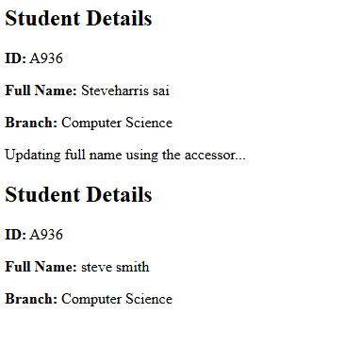

Experiment:8

Java Script Conditional Statements and Loops

1. Write a program which asks the user to enter three integers, obtains the numbers from the user and outputs HTML text that displays the larger number followed by the words “LARGER NUMBER” in an information message dialog. If the numbers are equal, output HTML text as “EQUAL NUMBERS”.

Source code:

<!DOCTYPE html>

<html>

    <head>

        <title>largest number</title>

        <script>

            function Largest()

{

                let num1=prompt("enter the first number");

                let num2=prompt("enter the second number");

                let num3=prompt("enter the third number");

                if(num1==num2&&num2==num3)

            {

                alert("equal numbers");

            }

            else{

                let larger=Math.max(num1,num2,num3);

                alert(larger+"larger number");

            }

            }

        </script>

</head>

    <body>

        <h1>find the largest of 3 number</h1>

        <button onclick="Largest()">find the largest number</button>

    </body>

</html>

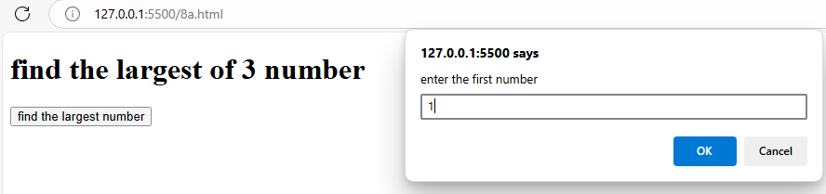

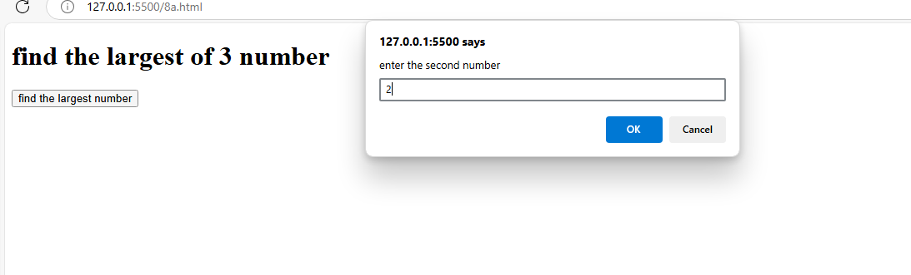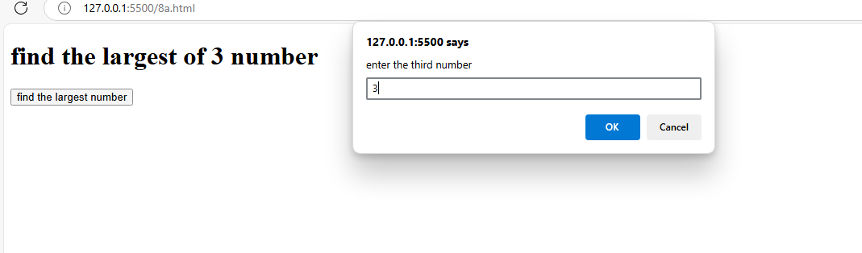

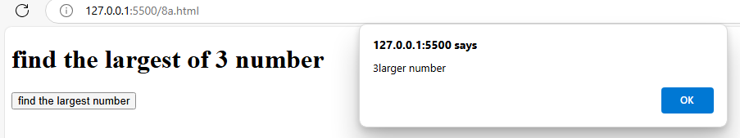

1. Write a program to display week days using switch case.

<!DOCTYPE html>

<html>

    <head>

        <title>sample</title>

        <script>

            function Weekdays()

            {

                let day=parseInt(prompt("enter value"));

                switch(day)

                {

                    case 1:

                        alert("sunday");

                        break;

                        case 2:

                            alert("monday ");

                            break;

                            case 3:

                                alert("tuesday");

                                break;

                                case 4:

                                    alert("wednesday");

                                    break;

                                    case 5:

                                        alert("thursday");

                                        break;

                                        case 6:

                                            alert("friday");

                                            break;

                                            case 7:

                                                alert("saturday");

                                                break;

                            default:

                                alert("incorrect number!plz enter from 1 to 7");

                }

            }

        </script>

    </head>

    <body>

        <h1>check the Weekdays</h1>

        <button onclick="Weekdays()">Weekdays</button>

    </body>

</html>

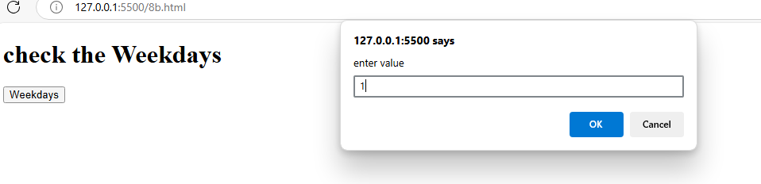

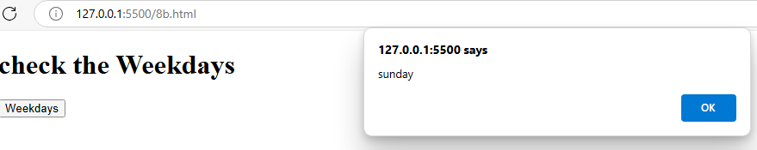

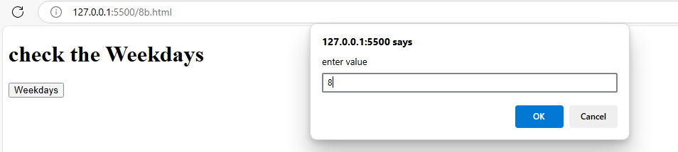

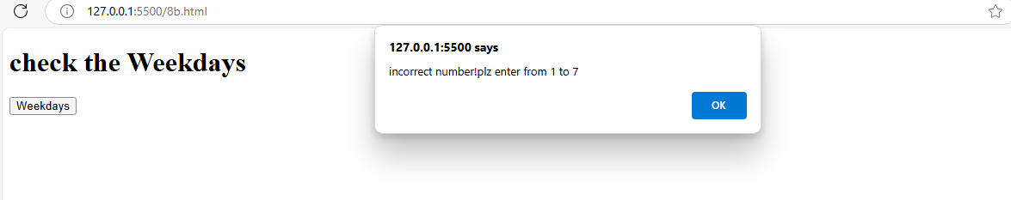

1. Write a program to print 1 to 10 numbers using for, while and do-while loops.

<!DOCTYPE html>

<html>

    <head>

        <title>do while example</title>

        <script>

            function Printnumbers()

            {

                let output="using for loop:";

                for(let i=1;i<=10;i++)

            {

                output +=i;

            }

            document.getElementById("for").innerHTML=output;

            //whileloop

            output1="<br>using while loop:";

            let i=1;

            while(i<=10)

            {

                output1 +=i+" ";

                i++;

            }

            document.getElementById("while").innerHTML=output1;

            //do-whileloop

            output2="<br>using do-while loop:";

            i=1;

            do{

                output2 +=i+" ";

                i++;

            }while(i<=10);

            document.getElementById("dow").innerHTML=output2;

            }

        </script>

    </head>

    <body>

        <button onclick="Printnumbers()">print numbers from 1 to 10</button>

        <div id="for"></div>

        <div id="while"></div>

        <div id="dow"></div>

    </body>

</html>

Output:

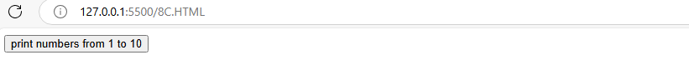

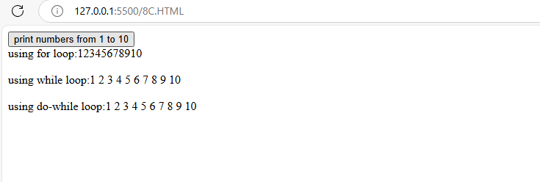

1. Write aprogram to print data in object using for-in, for-each and for-of loops.

<!DOCTYPE html>

<html>

    <head>

        <title>for in and for each</title>

        <script>

            function loopThroughObject()

            {

                let person={

                    name:"steve harris",

                    age:18,

                    city:"chirala"

                };

                let output="using for in loop";

                for(let key in person)

                {

                    output +=key + ":"+person[key]+"<br>";

                }

                output +="using for-each loop";

                Object.entries(person).forEach(([key,value])=>{

                    output +=key + ":"+value+"<br>";

                });

                output +="using for-of loop";

                for (const[key,value]of Object.entries(person)){

                    output +=key+":"+value+"<br>";

                }

                document.getElementById("output").innerHTML=output;

            }

        </script>

    </head>

    <body>

        <button onclick="loopThroughObject()">Loop through object</button>

        <div id="output"></div>

    </body>

</html>

Output:

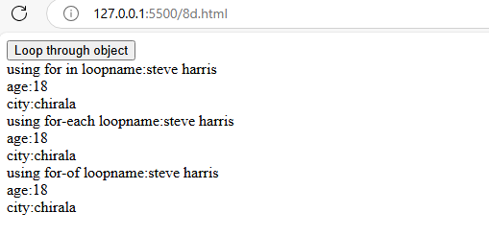

1. Develop a program to determine whether a given number is an ‘ARMSTRONG NUMBER’ or not. [Eg: 153 is an Armstrong number, since sum of the cube of the digits is equal to the number i.e.,13 + 53+ 33 = 153]

<!DOCTYPE html>

<html>

    <head>

        <title>armstrong number or not</title>

        <script>

            function Armstrong()

            {

                let num=parseInt(prompt("enter the number"));

                let sum=0;

                let temp=num;

                let digits=num.toString().length;

                while(temp>0)

            {

                let digit=temp%10;

                sum +=Math.pow(digit,digits);

                temp=Math.floor(temp/10);

            }

            if(sum==num)

            {

                alert(num+"is an armstrong number");

            }

            else{

                alert(num+"is not armstrong number");

            }

            }

        </script>

    </head>

    <body>

        <button onclick="Armstrong()">check armstrong or not</button>

    </body>

</html>

Output:

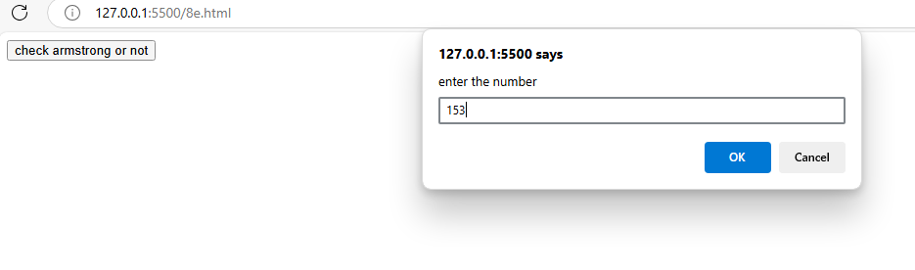

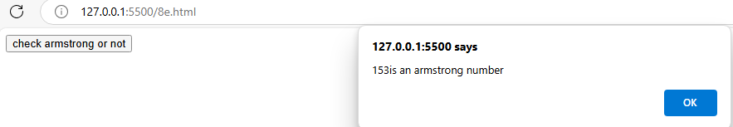

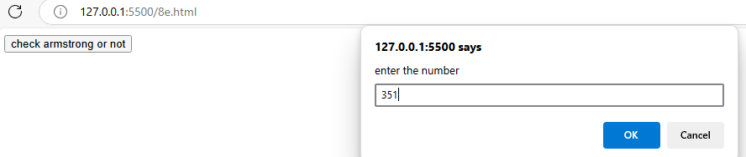

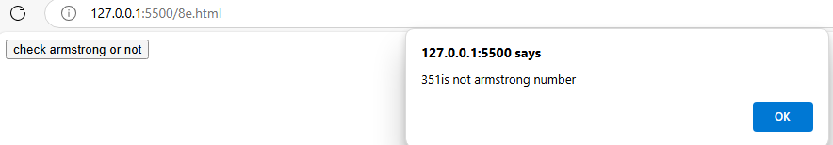

1. Write a program to display the denomination of the amount deposited in the bank in terms of 100’s, 50’s, 20’s, 10’s, 5’s, 2’s & 1’s. (Eg: If deposited amount is Rs.163, the output should be 1-100’s, 1-50’s, 1- 10’s, 1-2’s & 1-1’s).

<!DOCTYPE html>

<head>

    <script>

        function calculateDenominations()

        {

            let amount=parseInt(prompt("enter the amount to deposite"));

            let denominations=[100,50,20,10,5,2,1];

            let result="";

            for(let i=0;i<denominations.length;i++)

        {

            let count=Math.floor(amount/denominations[i]);

            if(count>0)

        {

            result +=count+"-"+denominations[i]+"'s, ";

            amount=amount%denominations[i];

        }

        }

        alert(result.slice(0,-2));//to remove last comma and space

        }

    </script>

</head>

<body>

    <button onclick="calculateDenominations()">calculate denominations</button>

</body>

</html>

Output:

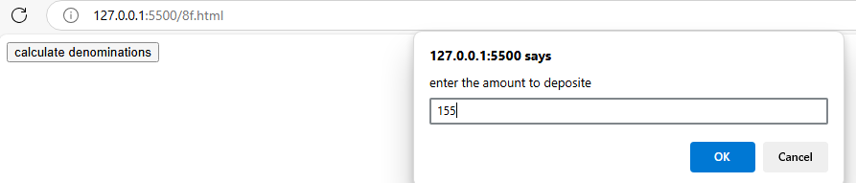

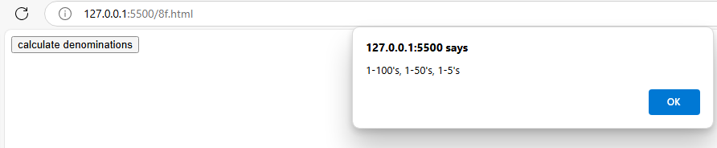

Experiment:9

Java Script Functions and Events

1. Design a appropriate function should be called to display i. Factorial of that number ii. Fibonacci series up to that number iii. Prime numbers up to that number iv. Is it palindrome or not.
2. Design a HTML having a text box and four buttons named Factorial, Fibonacci, Prime, and Palindrome. When a button is pressed an appropriate function should be called to display i. Factorial of that number ii. Fibonacci series up to that number iii. Prime numbers up to that number iv. Is it palindrome or not

<!DOCTYPE html>

<head>

    <title>number of operations</title>

</head>

<body>

    <div>

        <h2>number operations</h2>

        <input type="number" id="numberInput" placeholder="enter a number">

        <button onclick="Factorial()">Factorial</button>

        <button onclick="Fibonacci()">Fibonacci</button>

        <button onclick="Primenum()">Prime numbers</button>

        <button onclick="Palindrome()">Palindrome</button>

        <div id="result"></div>

    </div>

    <script>

        //Factorial

        function Factorial(){

            let num=document.getElementById('numberInput').value;

            num=parseInt(num);

            if(isNaN(num)||num<=0)

        {

            document.getElementById('result').innerHTML="please enter a positive number";

            return;

        }

        let result=1;

        for(let i=1;i<=num;i++)

        {

            result *=i;

        }

        document.getElementById('result').innerHTML='Factorial of'+num+'is:'+result;

        }

        //Fibonacci

        function Fibonacci(){

            let num=document.getElementById('numberInput').value;

            num=parseInt(num);

            if(isNaN(num)||num<=0){

                document.getElementById('result').innerHTML="please enter a positive integer";

                return;

            }

            let fib=[0,1];

            for(let i=2;i<num;i++)

            {

                fib.push(fib[i-1]+fib[i-2]);

            }

            document.getElementById('result').innerHTML='Fibonacci series upto'+num+'is:'+fib.join(',');

        }

        //prime number

        function Primenum(){

            let num=document.getElementById('numberInput').value;

            num=parseInt(num);

            if(isNaN(num)||num<2){

                document.getElementById('result').innerHTML="please enter a number greaterthan or eqaul to 2";

                return;

            }

            let primes=[];

            for(let i=2;i<=num;i++)

            {

                let isPrime=true;

                for(let j=2;j<=Math.sqrt(i);j++)

            {

                if(i%j===0)

            {

                isPrime=false;

                break;

            }

            }

            if(isPrime){

                primes.push(i);

            }

            }

            document.getElementById('result').innerHTML='prime numbers  upto'+num+'is:'+primes.join(',');

        }

        //palindrome

        function Palindrome(){

            let num=document.getElementById('numberInput').value;

            if(isNaN(num))

        {

            document.getElementById('result').innerHTML="please enter valid number";

            return;

        }

        let strnum=num.toString();

        let reversed=strnum.split('').reverse().join('');

        if(strnum==reversed)

        {

            document.getElementById('result').innerHTML=num+'is a plindrome';

        }

        else {

            document.getElementById('result').innerHTML=num+'is not a plaindrome';

        }

                        }

    </script>

</body>

</html>

Output:

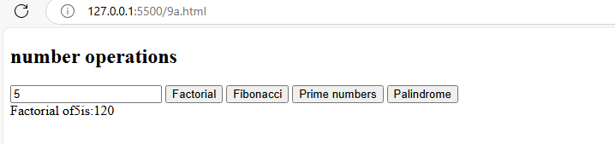

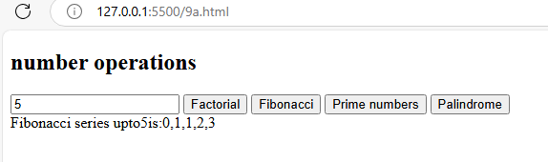

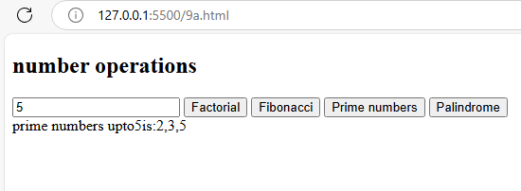

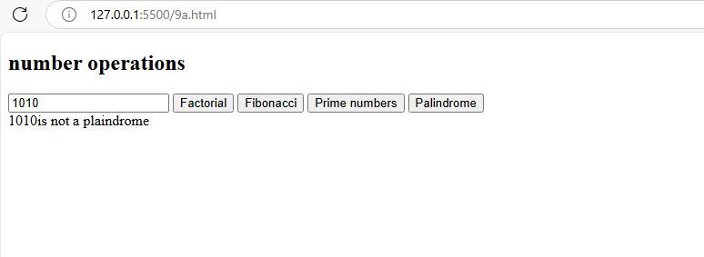

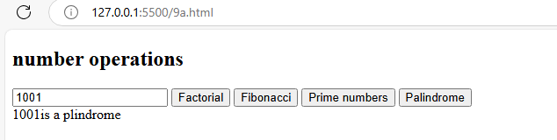

1. Write a program to validate the following fields in a registration page. i.Name (start with alphabet and followed by alphanumeric and the length should not be less than 6 characters) ii. Mobile (only numbers and length 10 digits) iii. E-mail (should contain format like [xxxxxxx@xxxxxx.xxx](mailto:xxxxxxx@xxxxxx.xxx))

<!DOCTYPE html>

<html>

    <head>

        <title>registration form validation</title>

    </head>

    <body>

        <div>

            <h2>

                registration form

            </h2>

            <form id="registrationform">

            <input type="text" id="name" placeholder="enter your name" required><br>

            <input type="text" id="mobile" placeholder="enter your mobile number" required><br>

            <input type="email" id="email" placeholder="enter your email id" required><br>

                <button type="submit">submit</button>

            </form>

            <div id="errormessage"></div>

        </div>

        <script>

            function validatename(name){

                //starts with alphabetic,followed by alphanumeric characters,min 6 characters

                const nameregex=/^[A-Za-z][A-Za-z0-9]{5,}$/;

                return nameregex.test(name);

            }

            function validatemobile(mobile){

                const mobileregex=/^\d{10}$/;

                return mobileregex.test(mobile);

            }

            function validateemail(email){

                const emailregex=/^[a-zA-Z0-9._]+@[a-zA-Z0-9]+\.[a-zA-Z]{2,6}$/;

                return emailregex.test(email);

            }

            document.getElementById('registrationform').addEventListener('submit',function(event)

        {

            event.preventDefault();

            const name=document.getElementById('name').value;

            const mobile=document.getElementById('mobile').value;

            const email=document.getElementById('email').value;

            let errormessages='';

            if(!validatename(name)){

                errormessages +='starts with alphabetic,followed by alphanumeric characters,min 6 characters<br>';

                }

                if(!validatemobile(mobile)){

                errormessages +='mobile number should be numbers and 10 digits only<br>';

                }

                if(!validateemail(email)){

                errormessages +='email id should be in right format<br>';

                }

                if(errormessages){

                    document.getElementById('errormessage').innerHTML=errormessages;

                }

                else{

                    document.getElementById('errormessage').innerHTML='registration succesfull';

                }

        });

        </script>

    </body>

</html>

Output:

